Mockbot



By:

Maryam Malik – Team Member 1
31510
Musabbiha Zahid – Team Member 2
35458
Mahnoor Tanzeel Satti – Team Member 3
35913

Supervised by:
Dr.Sumera Saleem

Faculty of Computing
Riphah International University, Islamabad
Fall 2024

A Dissertation Submitted To

Faculty of Computing,

Riphah International University, Islamabad

As a Partial Fulfillment of the Requirement for the Award of
The Degree of
Bachelors of Science in Software Engineering

Faculty of Computing

Riphah International University, Islamabad
Date: 21-November-2024

Final Approval

This is to certify that we have reviewed the project report submitted by Maryam Malik(31510), Mahnoor Tanzeel Sattti (35913), and Musabbiha Zahid (35458) as partial fulfillment of the requirements for the Bachelor of Science in Software Engineering (BSSE) degree. The report presents a comprehensive system, MockBot, an AI-powered interview preparation platform. This innovative project showcases a high level of technical proficiency, addressing critical needs in accessible interview preparation, soft skills assessment, and talent visibility for recruiters. We find the report meets the standards required for acceptance by Riphah International University, Islamabad, toward the BSSE degree.

Committee:

1

Dr.Sumera Saleem
(Supervisor)

2

Ms. Tahira Nazir
(Head of Department/chairman)

Declaration
We hereby declare that this document, "MockBot" neither as a whole nor in part, has been copied from any source. We further declare that we have completed this project, along with the accompanying report, entirely through our own efforts and under the proficient guidance of our teachers, particularly our supervisor, Dr.Sumera Saleem. If any part of the system is proven to be copied from any source or found to be a reproduction of any other project, we acknowledge responsibility for any resulting consequences.

Maryam Malik
31519

Musabbiha Zahid
35458

Mahnoor Tanzeel Satti
35913

Dedication
With heartfelt gratitude to Allah Almighty for granting us the strength and perseverance to complete this final year project report. Special thanks to our dedicated supervisor, Dr. Sumera Saleem, whose invaluable guidance and support were instrumental throughout the development of MockBot. We also extend our deepest appreciation to each team member, whose hard work and commitment were essential in bringing this project to life. Your dedication turned challenges into achievements, transforming our ideas into a reality.

Abstract
In today’s competitive job market, interview preparation often requires costly coaching and access to resources, creating barriers for many candidates. MockBot addresses these challenges by offering a free, accessible AI-powered platform for interview preparation. Instead of relying on in-person coaching, MockBot provides a simulated interview experience through multiple-choice questions that test both technical skills (IQ) and emotional intelligence (EQ). This dual assessment ensures a well-rounded preparation, equipping candidates not only with knowledge but also with the soft skills crucial for modern workplaces, such as handling pressure, effective communication, and teamwork. MockBot adapts its question bank based on user performance, guiding candidates through progressively challenging levels to build confidence and competence. Additionally, MockBot offers a resume optimization tool with ATS (Applicant Tracking System) analysis to help candidates enhance their resumes and improve their chances of passing initial screenings.MockBot aims to democratize interview preparation, making it accessible to individuals from all backgrounds. It provides a supportive and practical preparation environment, helping users build skills, gain visibility, and maximize their potential in today’s job market. MockBot aligns with SDG 4 (Quality Education) by fostering continuous learning opportunities through feedback and skill improvement. It supports SDG 8 (Decent Work and Economic Growth) by connecting job seekers with employment opportunities and helping employers assess talent effectively. By leveraging AI-driven innovation, MockBot contributes to SDG 9 (Industry, Innovation, and Infrastructure), promoting advanced tools in recruitment and education. Finally, MockBot addresses SDG 10 (Reduced Inequalities) by providing equitable access to preparation tools and enabling diverse candidates to compete on a level playing field.

Table Of Contents:

Chapter 1: Introduction 11
1.1 Opportunity & Stakeholders 12
1.2 Motivations and Challenges 13
1.3 Goals and Objectives 14
1.4 Solution Overview 15
1.5 Report Outline 15
Chapter 2: Literature / Market Survey 17
2.1 Introduction 17
2.2 Literature Review / Technologies overview 17
2.3 Market Research 17
2.4 Market Survey 17
SurvyForm 2.1: Company 21
SurvyForm 2.2: Jobseeker 24
2.5 Literature Review 31
2.6 Summary 34
Chapter 3: Requirement Analysis 36
3.1 Introduction 36
3.2 Problem Scenario 36
3.3 Functional Requirements 36
Chapter 4: System Design 47
4.1 Introduction 47
4.2 Architectural Design 47
4.3 Detailed Design 49
4.4 Fully Dressed Use Cases 56
Chapter 5: 81
Implementation 81
5.1 Endeavour (Team + Work + Way of Working) 82
Table 3 Planning 82
Table 4 Requirements Gathering 83
Table 5 Designing 83
Table 6 Implementation 83
Table 7 Testing 84
5.2 Flow Control/Pseudo codes 84
5.3 Components, Libraries, Web Services, and Stubs 84
5.4 Best Practices / Coding Standards 85
5.5 Deployment Environment 86
5.6 Summary 87
Chapter 6: 88
Testing and Evaluation 88
6.1 Introduction 89
6.2 List of test scenarios 89
6.3 Performance and evaluation 89
Appendix A: 90
System Sequence Diagram 90
Appendix B: 102
ActivityDiagram 102
Appenix C: 115
Test Scenarios 115
Appendix D: 139
Work Breakdown Structure 139
(WBS) 139
1. Project Initiation 140
2. Planning 140
3. System Design 140

Acknowledgement
First of all, we are grateful to Allah Almighty, the Merciful, the Beneficent, and the source of all knowledge, for granting us the courage and wisdom to complete this project. We extend our sincere thanks to our supervisor, Dr. Sumera Saleem, whose exceptional guidance enabled us to accomplish this project successfully. Additionally, we are thankful to our dedicated team, whose collective efforts and cooperation played a significant role in making this achievement possible.

Maryam Malik
31510

Musabbiha Zahid
35458

Mahnoor Tanzeel Satti
35913

Chapter 1: Introduction

Chapter 1: Introduction
In today’s competitive job market, securing employment often requires rigorous interview preparation, which can be challenging and costly for many candidates. Traditional coaching methods and resources can be financially prohibitive and limited in accessibility, leaving many job seekers without sufficient preparation tools. Candidates are not only expected to excel in technical skills but also demonstrate emotional intelligence, such as effective communication, adaptability, and resilience. Consequently, there is a growing need for an accessible system that provides well-rounded interview preparation by focusing on both intellectual and emotional aspects.
MockBot is designed to bridge this gap, offering a comprehensive, AI-powered interview preparation platform that is free and accessible to everyone. Through MockBot, candidates can practice interview-style multiple-choice questions that assess both technical abilities (IQ) and emotional intelligence (EQ), ensuring they are prepared for various aspects of real interview situations. This dual assessment aims to prepare candidates holistically, enhancing both their knowledge and soft skills critical for the workplace.
MockBot provides a customized learning experience, where questions adapt based on user performance, allowing candidates to progress through different levels of complexity and build confidence over time. Additionally, the platform offers a resume optimization tool that includes an Applicant Tracking System (ATS) analysis, helping candidates refine their resumes to meet the criteria of automated recruitment systems and increase their chances of success in early screening stages.
Candidates can also view comprehensive reports generated after each session, which provide valuable insights into their performance. These reports, along with academic profiles, are available to employers, allowing companies to identify and recruit talent based on objective measures of skill and emotional intelligence. MockBot facilitates a transparent and efficient hiring process, opening up new opportunities for both candidates and employers.
Ultimately, MockBot enhances interview preparation, creating an equitable platform that supports candidates from all backgrounds. By making essential resources accessible, MockBot empowers users to succeed in their career journeys and contributes to a more inclusive and supportive job market.

1.1 Opportunity & Stakeholders

1.1.1 Opportunity:
In today’s competitive job market, traditional interview preparation resources often require significant financial investment, creating barriers for many individuals who cannot afford paid coaching or access to advanced learning materials. This financial gap restricts candidates from fully preparing for interviews that assess not only technical skills but also soft skills such as emotional intelligence, adaptability, and resilience, which are essential in modern workplaces.
Many candidates seek affordable, effective ways to prepare for interviews that develop both their intellectual and emotional competencies. By leveraging AI, there is an opportunity to create an interview preparation system that provides personalized, cost-free resources. This system can help candidates enhance their job-specific knowledge and soft skills, better preparing them for the demands of today's job market. MockBot meets this need by providing an accessible, well-rounded interview preparation platform that caters to a wide range of candidates, democratizing the interview process and levelling the playing field.
1.1.2 Stakeholders:
- Employers:
Employers can view candidates’ academic profiles and performance reports, enabling them to assess both technical knowledge and soft skills.
The system helps employers identify potential talent based on objective measures, streamlining their recruitment process and supporting data-driven hiring decisions
- Interviewees:
Candidates are the primary users of MockBot.
They use the system to practice interview questions, assess both technical (IQ) and emotional intelligence (EQ) skills, and track their progress through performance reports, ultimately improving their readiness for real-world interviews.
- Educational Institutes:
Institutes can use the system to prepare their students for the job market, thus increasing the employability of their graduates.

1.2 Motivations and Challenges

1.2.1 Motivations:
The motivation behind building MockBot is to make interview preparation more accessible and effective in a world where competition is high, and traditional coaching can be costly and limited in scope. Many job seekers face barriers when it comes to accessing affordable, high-quality interview preparation resources. MockBot addresses this gap by providing an AI-driven, self-paced preparation tool that can simulate real interview scenarios. Unlike in-person coaching, which can be both expensive and inaccessible for many, MockBot uses technology to democratize the preparation process. It goes beyond testing technical knowledge by also evaluating essential soft skills such as emotional intelligence (EQ), making it a well-rounded preparation tool. By offering this resource for free, MockBot gives all candidates—regardless of their financial background—an opportunity to practice, improve, and showcase their skills to potential employers. MockBot is also designed to support companies in their hiring process. By providing companies with insights into candidates’ knowledge, mind-set, and readiness, MockBot bridges the gap between talent and opportunity. With tailored question banks, performance-based difficulty adjustments, and tools like ATS resume compatibility checks, MockBot helps job seekers not only prepare but also stand out to recruiters. This approach ultimately contributes to a more inclusive hiring ecosystem.
1.2.2 Challenges:
Developing MockBot presents unique challenges, both technical and user-centric. Common challenges include:
- Ensuring the platform remains easy to use for individuals with various levels of technical skills and interview experience.
- Tailoring difficulty levels and maintaining accurate, real-time adjustments based on candidate performance to provide a customized experience.
- Creating a robust algorithm that evaluates both technical skills and soft skills, especially emotional intelligence (EQ), which can be harder to quantify.
- Protecting candidates' personal data and academic profiles while also giving companies access to relevant information for hiring.
- Ensuring that resume analysis is accurate and compatible with widely-used Applicant Tracking Systems (ATS), while also keeping the process fast and reliable.
- Regularly updating question sets to reflect the changing demands of various industries, especially in technical and IT fields.

1.3 Goals and Objectives

1.3.1 Goals:
- To provide an accessible and user-friendly platform that simplifies interview preparation for job seekers, making the process more efficient and less stressful.
- To enhance the skills and confidence of candidates by offering realistic interview simulations and feedback, thereby improving their chances of success in the job market.
- To foster an engaging learning environment that motivates candidates to practice and refine both technical and soft skills, including emotional intelligence (EQ).
- To continuously evolve the platform based on user feedback and performance data, enhancing its effectiveness and relevance.
- To promote a fair and inclusive hiring process by offering insights into candidate readiness, ultimately benefiting both job seekers and employers.
- To improve candidates' readiness for job interviews by equipping them with the necessary skills and knowledge, thereby increasing their employability.
1.3.2 Objectives:
- To provide a completely free platform for interview preparation, ensuring that individuals from all backgrounds can access quality resources without financial constraints.
- To offer a holistic approach to interview preparation by assessing both technical knowledge (IQ) and soft skills (EQ) through AI-generated multiple-choice questions.
- To create a personalized learning experience by tailoring question difficulty levels.
- To enable talent visibility for candidates by allowing potential employers to view academic profiles and performance reports, facilitating a data-driven recruitment process.
- To empower candidates by providing tools for resume optimization.
- To ensure candidates receive immediate feedback on their performance in the form of scores, allowing them to track their progress and improve continuously.
- To provide insights into university performance through analytics, enabling students and institutions to identify areas for improvement and showcase top performers.

1.4 Solution Overview
MockBot is an easy-to-use online platform that helps people prepare for job interviews. It uses artificial intelligence to create practice interviews, making it affordable and accessible for everyone. The platform includes a variety of multiple-choice questions tailored for different job fields, covering not just technical skills but also important soft skills like emotional intelligence. Users can choose questions at different difficulty levels, allowing them to learn at their own pace. MockBot is completely free, removing any cost barriers for users. After each practice session, users receive detailed reports showing their performance, helping them identify areas for improvement. These reports can also be shared with potential employers, making it easier for candidates to find job opportunities. Some key features of MockBot include a tool to optimize resumes so they meet employer requirements, a centralized profile for candidates to display their qualifications, and analytics that rank universities based on student performance. This transparency benefits both candidates and employers by clearly showing what is expected in the hiring process. In short, MockBot is more than just a study tool; it empowers job seekers, promotes equal access to career opportunities, and streamlines the hiring process for companies.

1.5 Report Outline
In this report, we will provide a comprehensive overview of our system. To start, we conducted a detailed survey of existing applications, identifying their problems. We proposed solutions with implementation details. Next, we will cover requirement analysis, system design, and implementation. Finally, we will discuss the overall design implementation and testing of our system.

Chapter 2:
Literature / Market Survey

Chapter 2: Literature / Market Survey

2.1 Introduction
To address the challenges faced by job seekers in preparing for interviews and to facilitate a smoother recruitment process for employers, it is crucial to analyse existing interview preparation systems, identify their shortcomings, and explore enhancements. This understanding will guide the development of MockBot, a platform designed to positively impact both candidates and recruiters.

2.2 Literature Review / Technologies overview
The web application MockBot aims to revolutionize the interview preparation process by providing a comprehensive, accessible platform for job seekers. While there are several existing interview preparation systems, most of them are not free and often lack advanced features for candidate assessment. Many of these applications focus solely on interview preparation, without offering companies insights into candidates' scores or capabilities. MockBot addresses these shortcomings by offering a free service that includes assessments for technical skills, emotional intelligence, and intelligence quotient (IQ), allowing users to engage with a variety of interview scenarios. This not only aids candidates in honing their skills but also enables potential employers to view candidates' performance metrics for better hiring decisions.

2.3 Market Research
The term "market research" means a method for collecting data about the intended audience of a system. In today's dynamic business environment, market research is crucial for maintaining competitiveness. Various methods, such as surveys, face-to-face interviews, observations, and online analytics can be employed to conduct market research for the project.

2.4 Market Survey
A market survey is a comprehensive research and analysis process focused on a specific product or service within a market. We are conducting a market survey to gain a deeper understanding of our target audience, their preferences, and evolving needs. This survey will enable us to refine our products and services to better cater to our customers, ultimately enhancing their experience and satisfaction.
2.4.1 Sample Questionnaire:

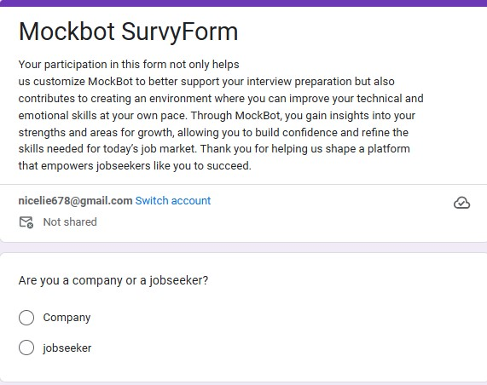

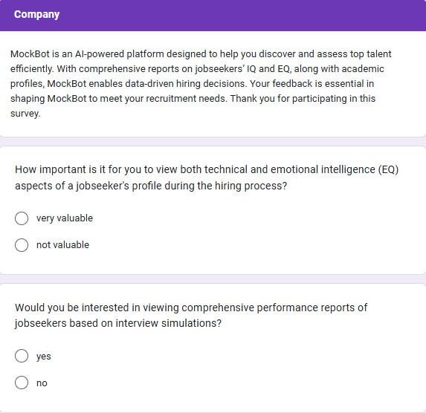

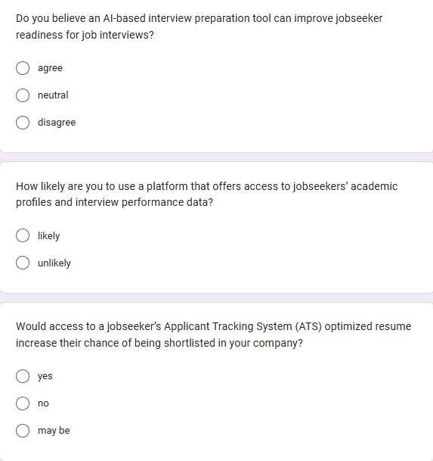

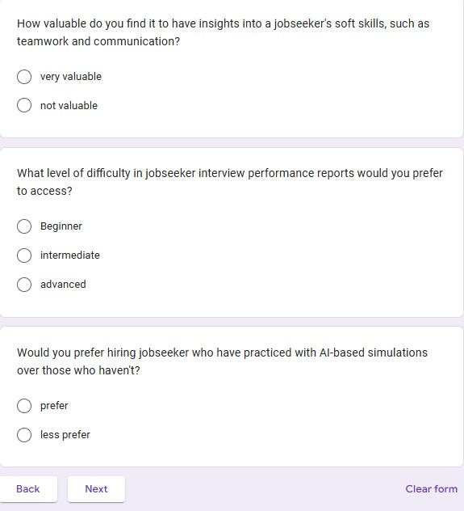

SurvyForm 2.1: Company

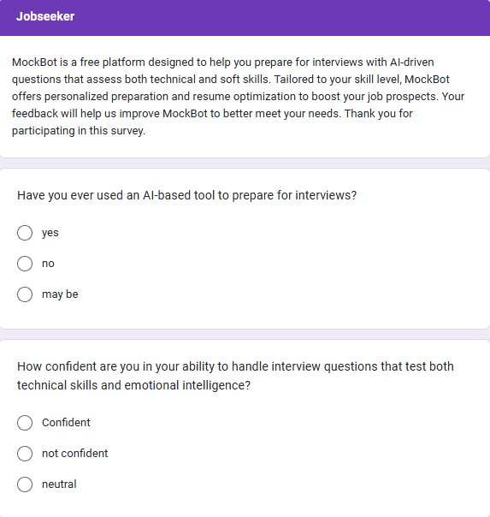
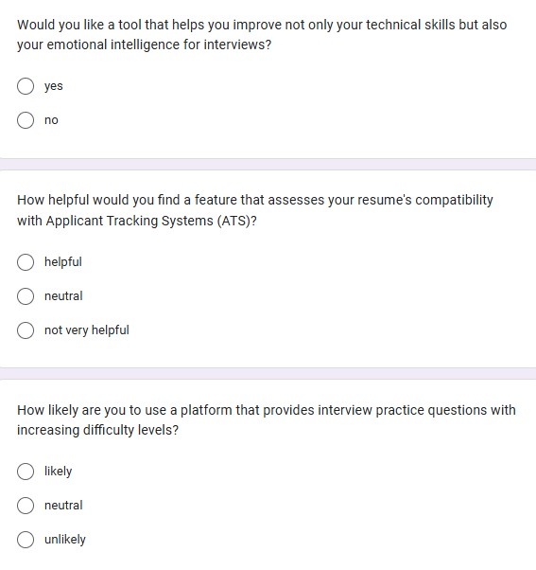
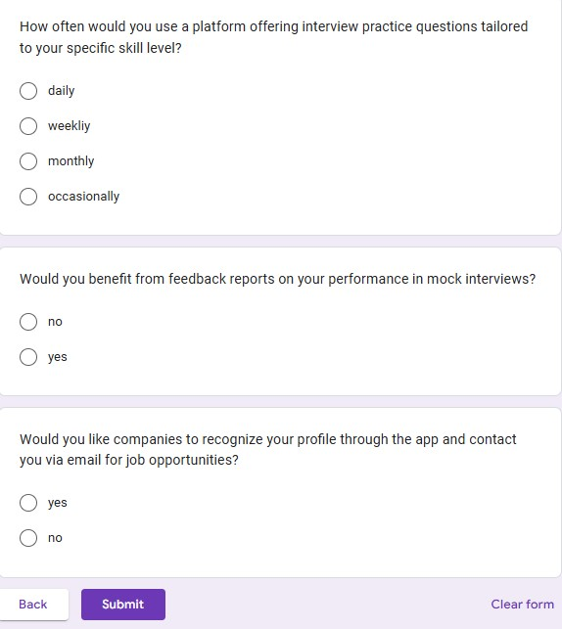

SurvyForm 2.2: Jobseeker

2.4.2 Graphs:
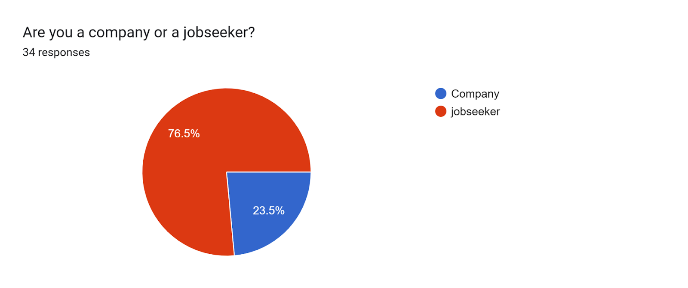

Figure 2.1: Company/Candidate Graph of Question
Company:
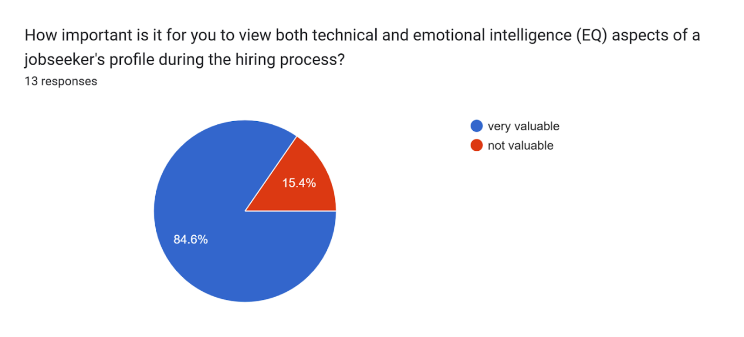
Figure 2.2: Graph of Question 01
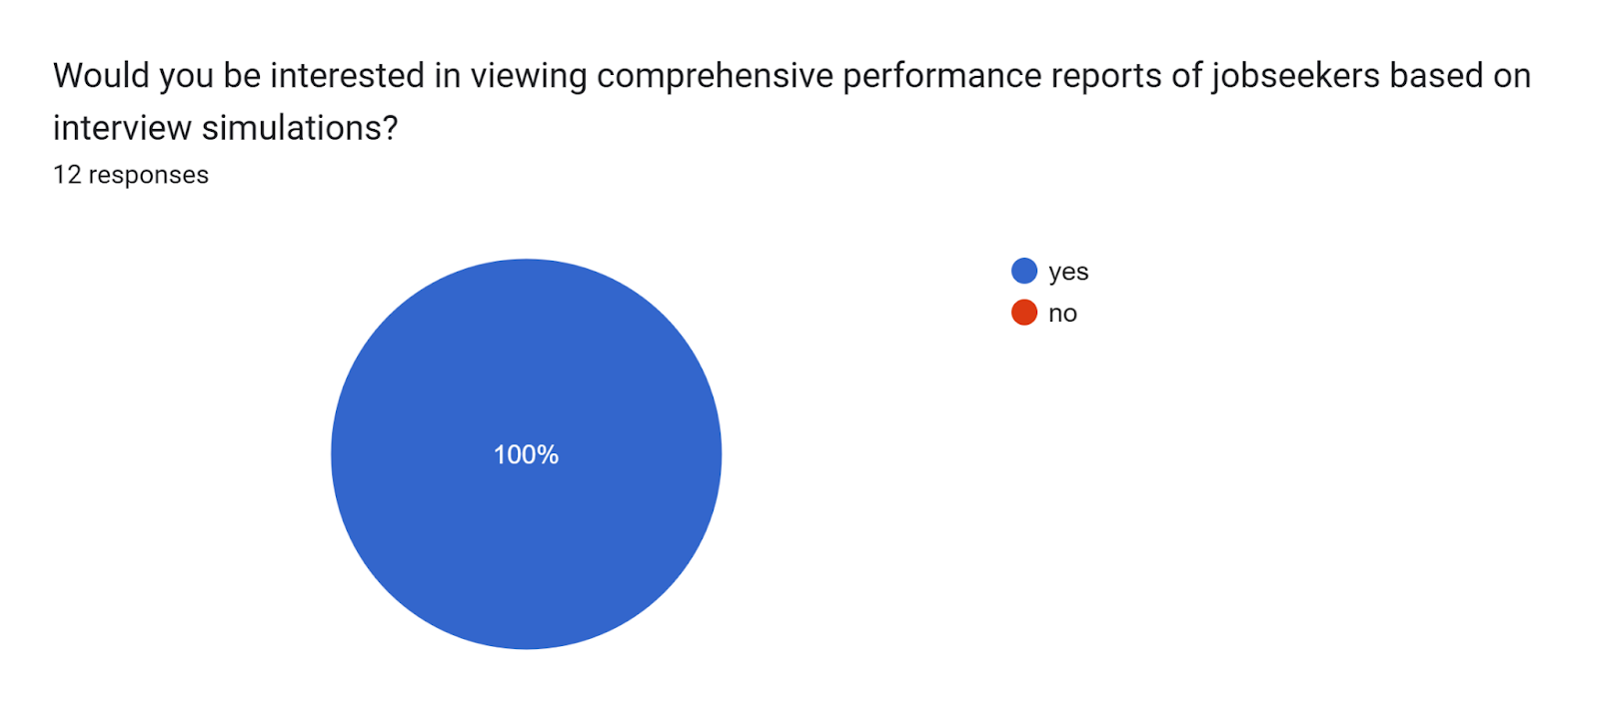
Figure 2.3: Graph of Question 02
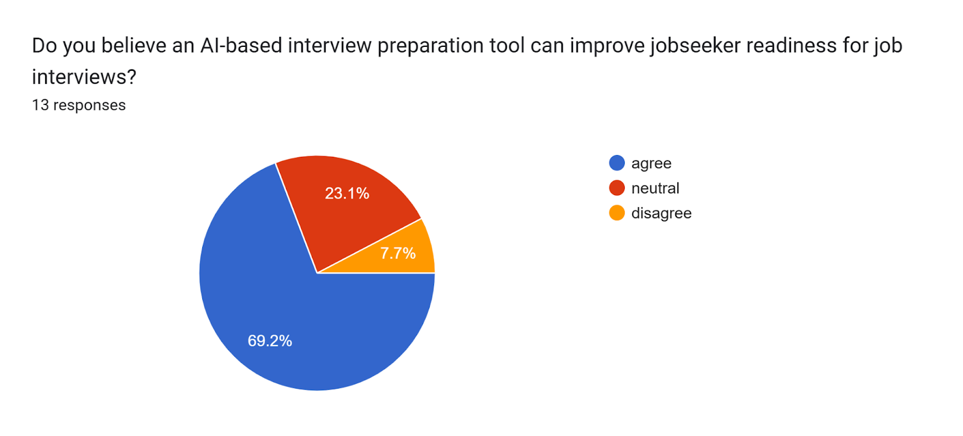

Figure 2.4: Graph of Question 03
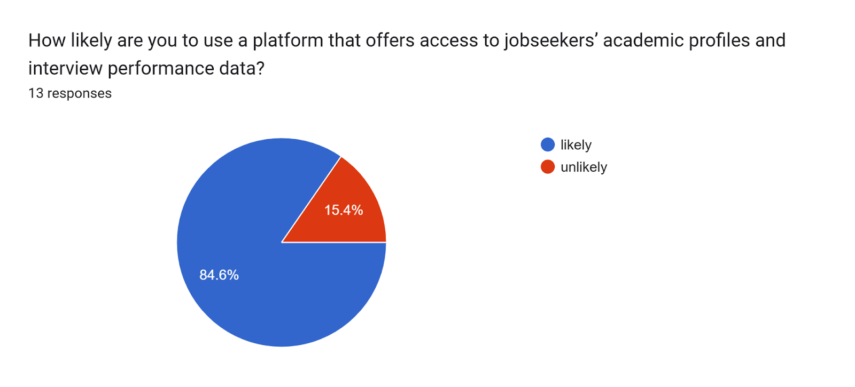
Figure 2.5: Graph of Question 04
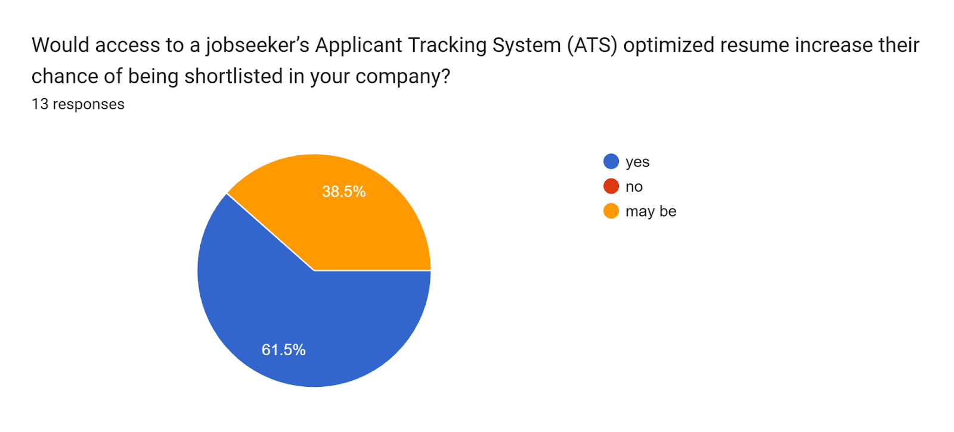
Figure 2.6: Graph of Question 05
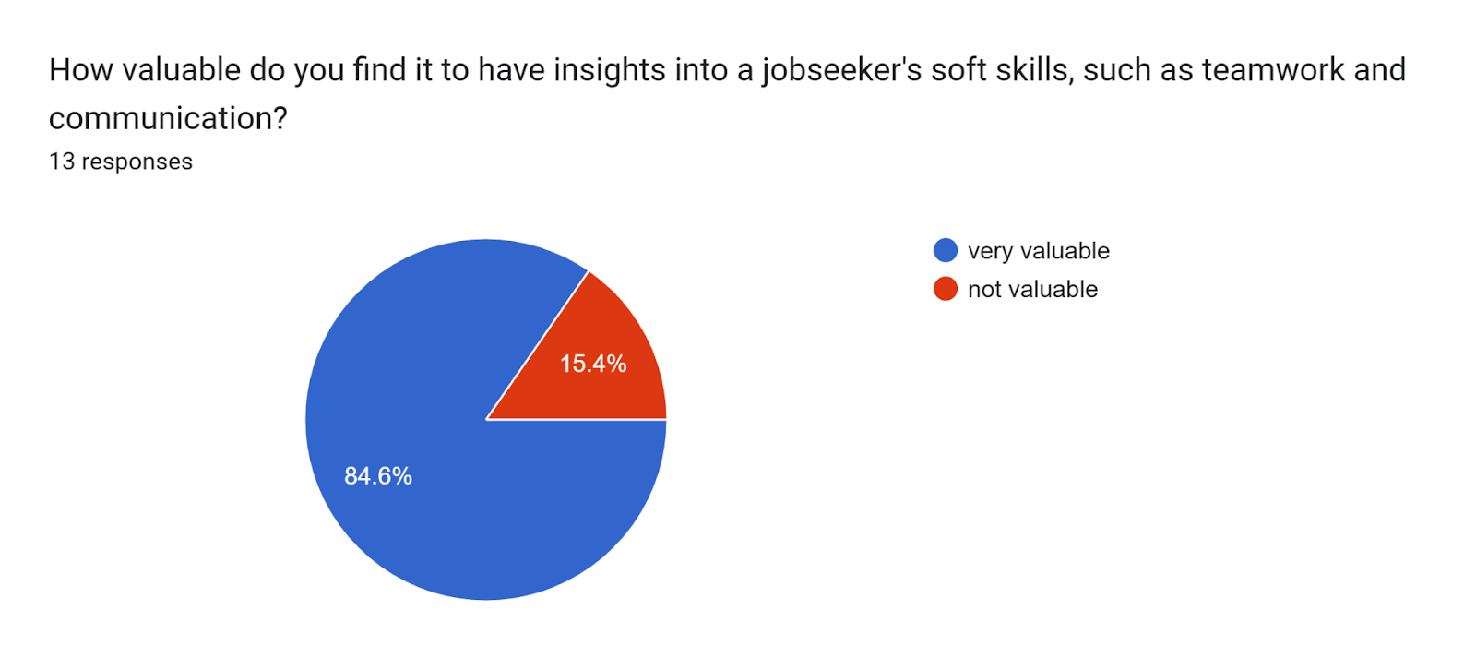
Figure 2.7: Graph of Question 06
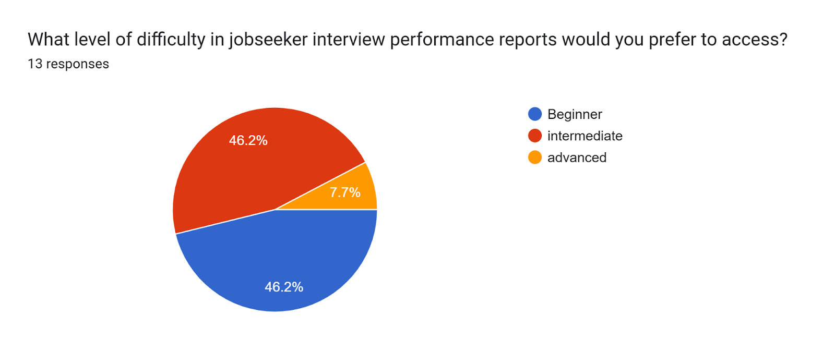
Figure 2.8: Graph of Question 07
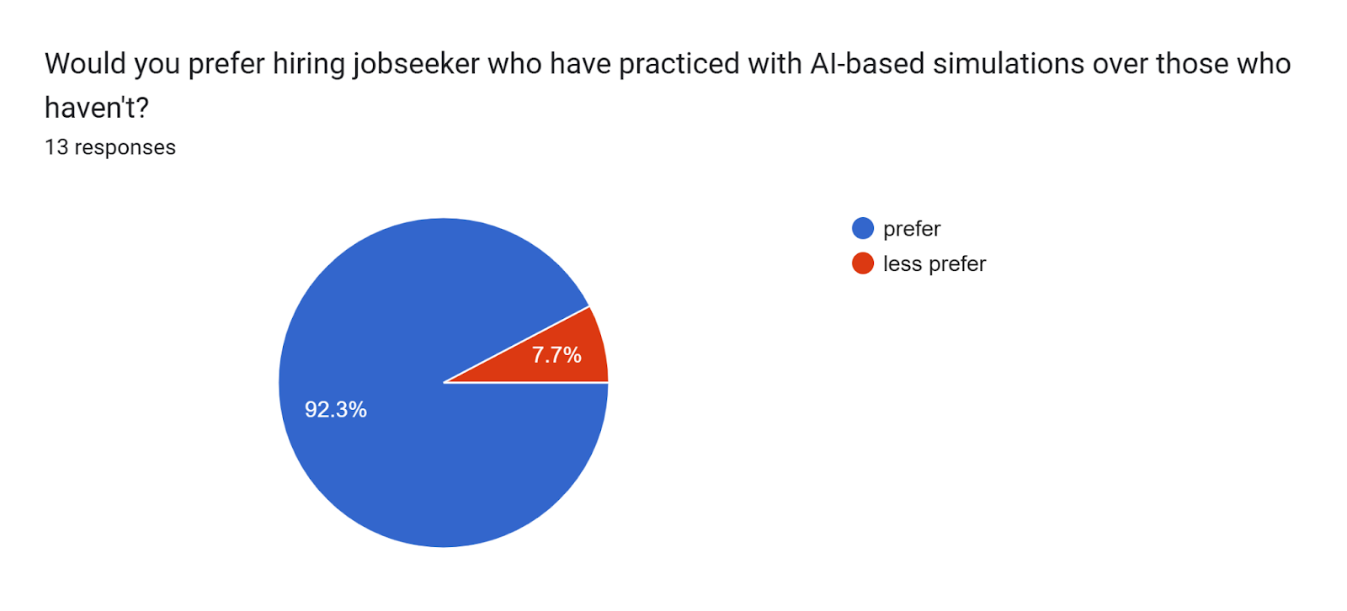
Figure 2.9: Graph of Question 08

Candidate:
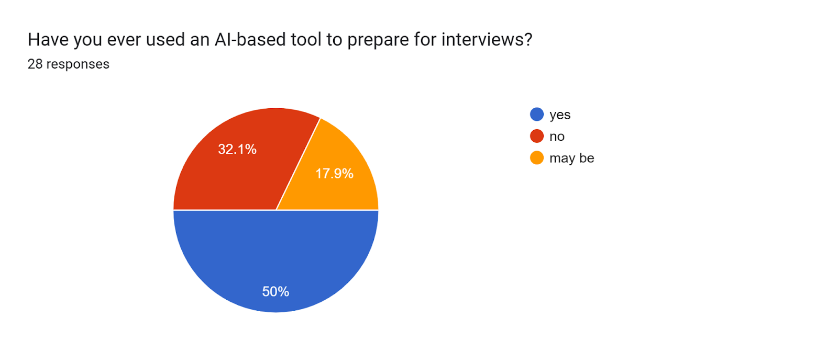
Figure 2.10: Graph of Question 01
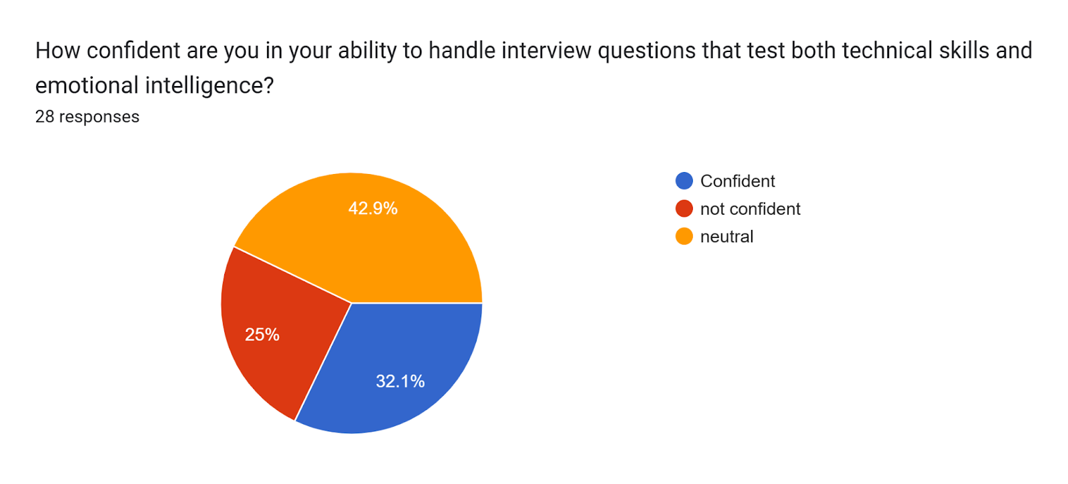
Figure 2.11: Graph of Question 02
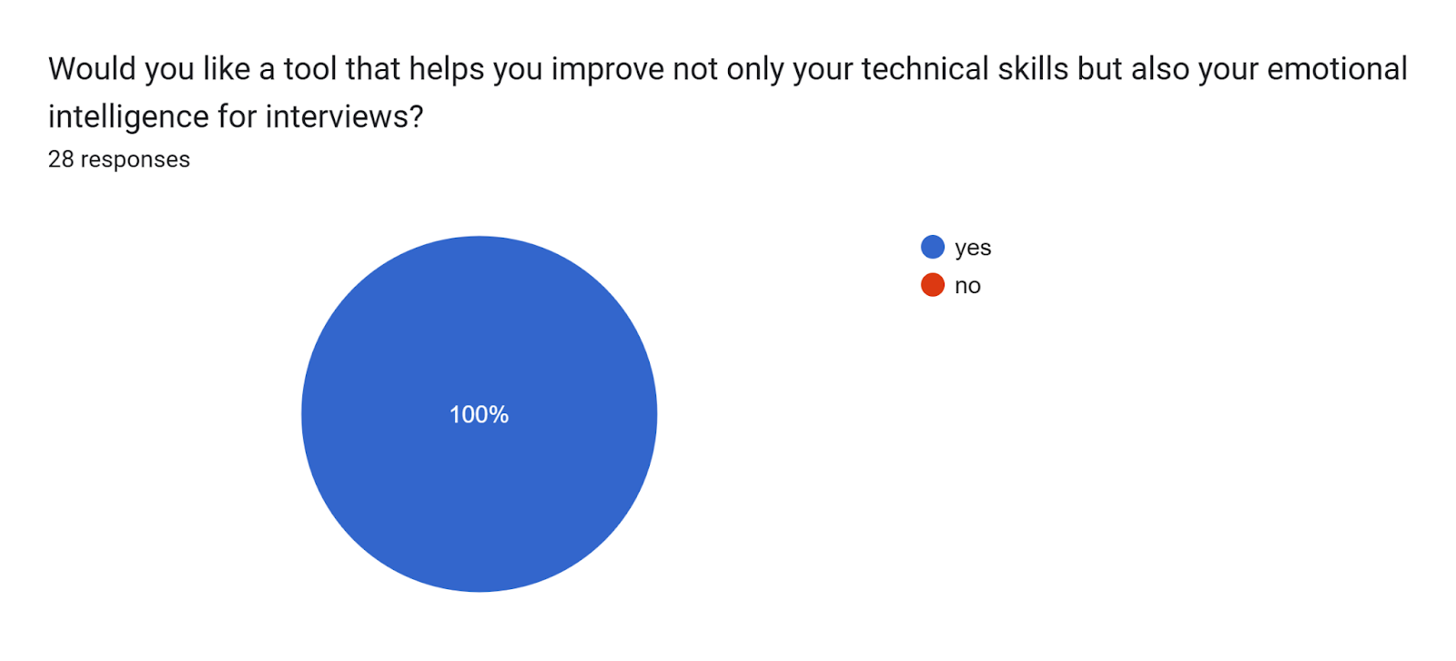
Figure 2.12: Graph of Question 03
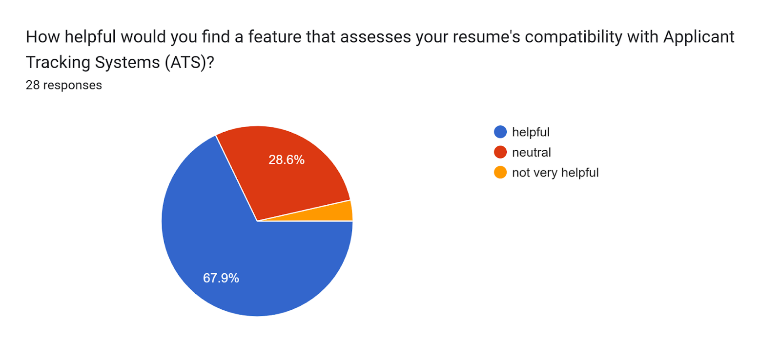
Figure 2.13: Graph of Question 04
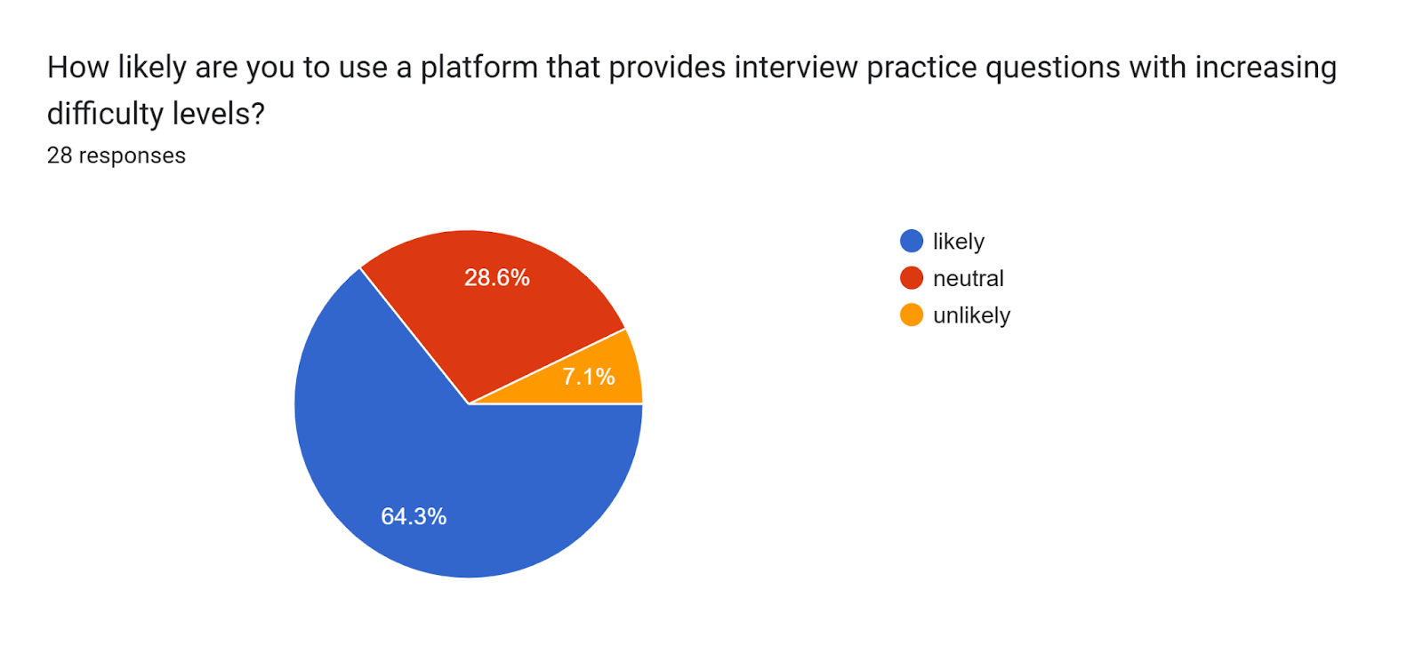Figure 2.14: Graph of Question 05 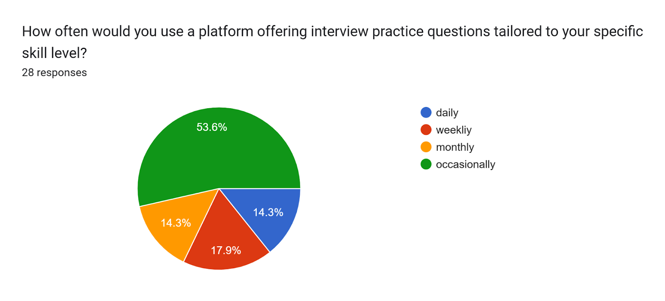
Figure 2.15: Graph of Question 06
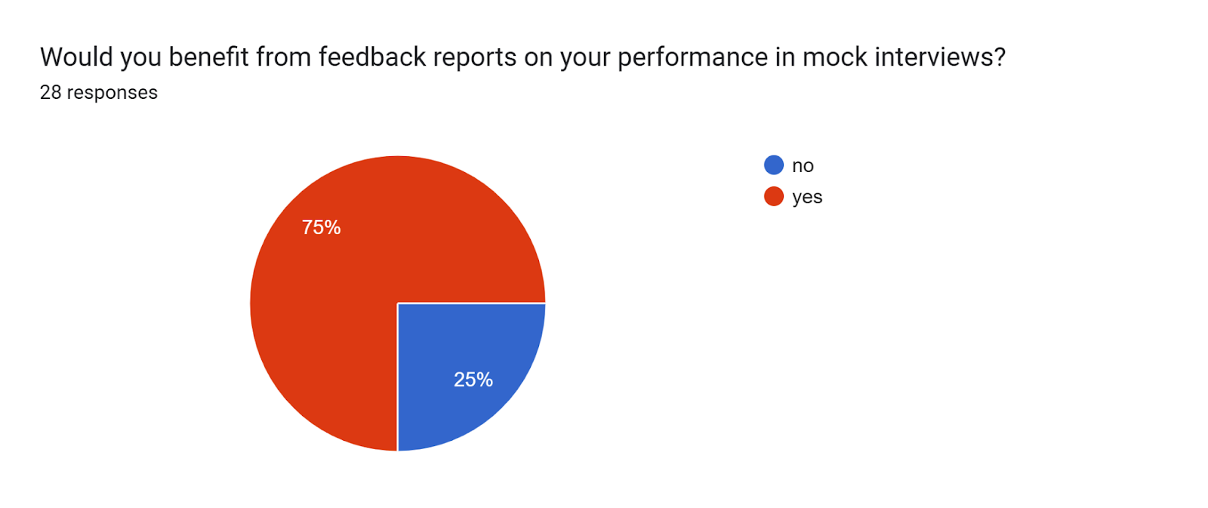
Figure 2.16: Graph of Question 07
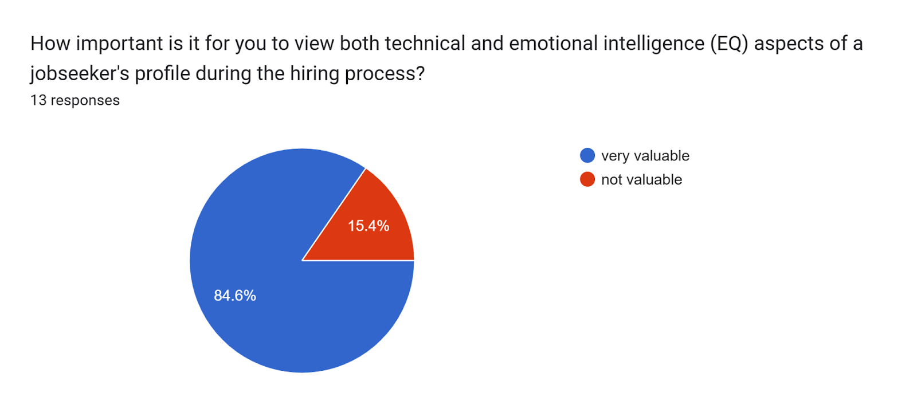
Figure 2.17: Graph of Question 08
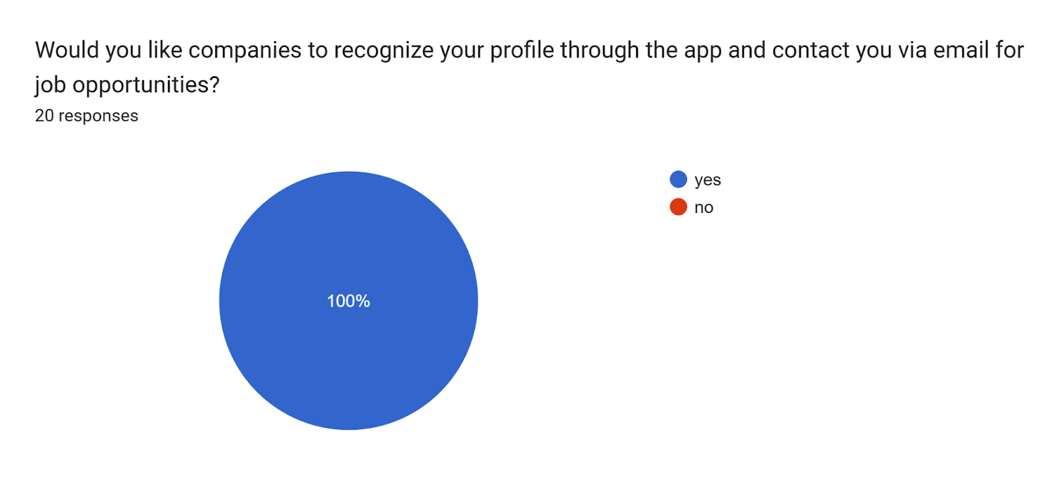
Figure 2.18: Graph of Question 09

2.4.3 Results:
Our analysis confirms that we have accurately identified our target audience and market needs.
Candidate:
- Interview Practice Interest: Around 64% of respondents are inclined to use a platform offering progressively challenging interview questions, showing strong demand.
- Mock Interview Feedback: Only 25% see value in feedback reports for mock interviews, suggesting this could be an area for further evaluation.
- Technical and EQ Profile Insight: 84.6% find it highly valuable to view technical and emotional intelligence (EQ) assessments in candidate profiles.
- Company Contact and Recognition: 100% support the idea of companies recognizing their profile and reaching out for job opportunities.
- Primary User Base: 76.5% of respondents are jobseekers, while 23.5% represent companies, confirming the main user base.
- AI-Powered Interview Tools: 69.2% agree that AI-based tools can enhance interview readiness.
Company:
- Access to Profiles and Data: 84.6% are likely to use a platform that provides access to candidates’ academic profiles and interview performance records.
- Performance Reports Interest: All respondents (100%) are interested in performance reports from interview simulations.
- ATS-Optimized Resume Value: 61.5% believe that an ATS-optimized resume make easy for selecting candidates.

2.5 Literature Review
A literature review is a comprehensive examination and analysis of existing knowledge. We engage in a literature review because it enables us to attain a profound grasp of the current systems in our chosen area of focus.

2.5.1 Literature Review on Mobile Applications
The mobile application on which we have done literature reviews are as follows:
- My Mock Interview
- Huru
- Jobma
- Interview AI

Features No. | System Name /Features |  | Mobile Applications |  |  | Proposed System
 |  | My Mock Interview | Huru | Jobma | Interview AI | MockBot
F-1 | AI-Technical Questions | X | ✓ | ✓ | ✓ | ✓
F-2 | Difficulty Levels | X | X | X | X | ✓
F-3 | Score Feedback | X | ✓ | X | X | ✓
F-4 | ATS Resume Analysis | X | X | ✓ | X | ✓
F-5 | Resume PDF Converter | X | X | X | X | ✓
F-6 | Talent Visibility | X | ✓ | ✓ | X | ✓
F-7 | Candidate Profile | ✓ | ✓ | ✓ | ✓ | ✓
F-8 | Candidate Registration | ✓ | ✓ | ✓ | ✓ | ✓
F-9 | Privacy setting | ✓ | X | X | X | ✓
F-10 | Logout for Candidate/ Company | ✓ | X | X | X | ✓
F-11 | Free Preparation Access | ✓ | X | X | X | ✓
F-12 | University Ranking Analytics | X | X | X | X | ✓
F-13 | Exposure of questions to Companies | X | X | X | X | ✓
F-14 | Company Registration | X | X | ✓ | X | ✓
F-15 | Emotional Quotient MCQS | X | X | X | X | ✓
F-16 | Intelligence Quotient MCQS | X | X | X | X | ✓
F-17 | Question Bank | X | X | X | X | ✓

Table 1 Literature Review on Mobile Applications
2.5.2 Literature Review on Web Applications
The web application on which we have done literature reviews are as follows:
- Prep Buddy
- Pramp
- Final Round AI
Features No. | System Name /Features | Web Applications |  |  | Proposed System
 |  | Prep Buddy | Pramp | Final Round AI | MockBot
F-1 | AI-Technical Questions | ✓ | X | ✓ | ✓
F-2 | Difficulty Levels | ✓ | X | X | ✓
F-3 | Score Feedback | ✓ | X | X | ✓
F-4 | ATS Resume Analysis | X | X | X | ✓
F-5 | Resume PDF Converter | X | X | X | ✓
F-6 | Talent Visibility | X | X | X | ✓
F-7 | Candidate Profile | ✓ | ✓ | ✓ | ✓
F-8 | Candidate Registration | ✓ | ✓ | ✓ | ✓
F-9 | Privacy setting | X | X | X | ✓
F-10 | Logout for Candidate/ Company | X | ✓ | ✓ | ✓
F-11 | Free Preparation Access | X | X | X | ✓
F-12 | University Ranking Analytics | X | X | X | ✓
F-13 | Exposure of questions to Companies | X | X | X | ✓
F-14 | Company Registration | X | X | X | ✓
F-15 | Emotional Quotient MCQS | X | X | ✓ | ✓
F-16 | Intelligence Quotient MCQS | X | X | X | ✓
F-17 | Question Bank | X | X | X | ✓

Table 2 Literature Review on Web Applications

It is analyzed that these web and mobile applications share common functionalities but also have certain limitations. For instance, company cannot hire, also cannot check EQ and IQ, some of them don’t have AI feature and no ATS analysis tool, among other limitations. In view of these restricted features, we are committed to enhance our web application to better serve our users and provide a more effective and user-friendly experience.

2.6 Summary
The MockBot system is a highly anticipated application, simplifying interview preparation by providing a comprehensive, accessible platform for candidates. It enhances preparation by monitoring candidates' progress and fostering engagement through various question types and difficulty levels. Through analysis of the market survey, we have identified a strong demand for such an application in the job market. Using insights from both the market survey and literature review, we will leverage this valuable data in the next chapter, Requirement Analysis, to refine and align the application’s features with user needs and market expectations.

Chapter 3:
Requirement Analysis

Chapter 3: Requirement Analysis

3.1 Introduction
In this chapter we will discuss problem scenarios, functional requirements, and non-functional requirements. We elicited functional and non-functional requirements based on literature survey and from key stakeholders.

3.2 Problem Scenario
- The main problem was that many interview preparation systems use costly AI tools that people have to buy, limiting access for those who can’t afford them.

- The Systems without Chatbot or AI-powered questions often need company professionals to teach, making them expensive and not free.

- Privacy policies keep user information hidden from companies, so skills and experience aren’t showcased. This leads to talented individuals missing out on job opportunities and recognition.

3.3 Functional Requirements
3.3.1: AI-Technical Questions
FR-1. The candidate shall select technical Multiple Choice Questions
FR-2: The system shall display options for technical fields.
FR-3: When the candidate selects the option from technical fields, the system shall generate the field’s related AI Multiple Choice question .
FR-4: After attempting each of the Technical Multiple Choice Questions, the candidate shall submit the test and receive scoring.
3.3.2: Difficulty Levels
FR-5: The system shall provide 3 difficulty levels: easy, medium and hard, for the Technical Multiple Choice Questions.
FR-6: In the easy level , the system shall generate multiple choice questions related to remembering.
FR-7: In the medium level, the system shall generate multiple choice questions related to understanding and applying.
FR-8: In the difficulty level, the system shall generate multiple choice questions related to analyzing and evaluating.
FR-9: The system shall conduct the easy level multiple choice questions within 25 minutes.
FR-10:The system shall conduct the medium level multiple choice questions within 30 minutes .
FR-11: The system shall conduct the medium level multiple choice questions within 10 minutes.
FR-12: The system shall provide 4 attempts for the easy level of Technical Multiple Choice Questions.
FR-13: The system shall provide 3 attempts for the medium level of Technical Multiple Choice Questions.
FR-14: The system shall provide 1 attempt for the hard level of Technical Multiple Choice Questions.
3.3.3: Score Feedback
FR-15: After the candidate submits the test, the system shall display the score of the Multiple Choice Question (MCQ) test, along with emotional and intelligence score interpretations.
FR-16: The candidate shall view scores of the MCQ test, including emotional intelligence and intelligence question results, categorized as follows:
Emotional Intelligence:
Total Score ≥ 130: Display "High Emotional Intelligence."
95 < Total Score < 130: Display "Moderate Emotional Intelligence."
Total Score ≤ 95: Display "Low Emotional Intelligence."
Intelligence Questions:
12/12: Display "Likely to fall into the above-average intelligence category (potentially 95th percentile or higher)."
9–11/12: Display "Typically considered high-average intelligence."
7–8/12: Display "May indicate average intelligence."
5–6/12: Display "Can be interpreted as below-average intelligence."
0–4/12: Display "Usually suggests low-average or below-average intelligence."
FR-17: The system shall upload the candidate's test scores
3.3.4: ATS Resume Analysis
FR-18: The candidate shall upload the resume.
FR-19: The system shall analyze the resume of the candidate.
FR-20: The system shall detect ATS structure.
FR-21: If the resume is according to ATS structure, the system shall accept the resume.
3.3.5: Resume PDF Converter
FR-22: The candidate shall access the PDF conversion tool from the resume submission interface.
FR-23: The system shall accept resume uploads in various formats (e.g., DOCX).
FR-24: The system shall convert resumes to PDF format while preserving layout and formatting.
FR-25: The candidate shall download converted PDF.
3.3.6: Talent Visibility
FR-26: The system shall allow companies to view candidates’ academic profiles, including institutions
FR-27: The system shall display candidates' interview test scores AND feedback to potential employers in a secure manner.
FR-28: The visibility of academic profiles AND interview scores shall be configurable based on candidates' privacy settings.
3.3.7: Candidate Profile
FR-29: The system shall navigate to the Profile section and display the current profile information, including name, university name, subject, and email.
FR-30: The system shall provide an "Edit" option on the Profile section, allowing candidates to update their information.
FR-31: The system shall enable profile fields for editing when the "Edit" option is selected, including name, university name, subject, and email.
FR-32: The system shall validate updated information for accuracy, such as ensuring proper email format and restricting invalid characters in text fields.
FR-33: The system shall check the completeness of all required fields (e.g., name, email) before saving the updated profile.
FR-34: The system shall provide a "Save" button to confirm the changes made to the profile information.
FR-35: The system shall save the updated profile information successfully upon selecting the "Save" option.
FR-36: The system shall display a confirmation message, such as "Profile updated successfully," after saving the updated information.
FR-37: The system shall not allow saving incomplete or invalid profile information and will display appropriate error messages.
FR-38: The system shall restrict unauthorized access to the Profile section, ensuring only the logged-in candidate can view and edit their profile.
3.3.8: Candidate Registration:
FR-39: The system shall allow the candidate to view an interface prompting them to enter their email and password for login.
FR-40: The system shall allow the candidate to view an interface prompting them to provide additional information such as username, email, password, and university name for signing up.
FR-41: The system shall allow the candidate to submit the required information (e.g., username, email, password, university name) to create a new account during the signup process.
FR-42: The system shall allow the candidate to submit their email and password to authenticate their account.
FR-43: The system shall allow the display of appropriate error messages for invalid email or password inputs, guiding the candidate to re-enter their information correctly.
3.3.9: Privacy setting
FR-44: The system shall allow users to control the visibility of their personal information such as name, contact details, and address in their profiles.
FR-45: The system shall notify users of changes in their privacy settings through email or in-app notifications.
3.3.10: Logout for Candidate/Company
FR-46: The system shall allow the user to view a "logout" option accessible from the user’s dashboard .
FR-47: The system shall allow the user to click the "logout" option, which will securely terminate the current session.
FR-48: Upon logging out, the system shall direct the user back to the home page.
FR-49: The system shall ensure that all user session data is securely cleared upon logging out, preventing unauthorized access to any user information.
3.3.11: Free Prep Access
FR-50: The system shall provide candidates completely free access to all interview preparation materials, including AI-technical, Intelligence quotient and emotional quotient related multiple choice questions AND resume optimization tools to every registered user without any payment requirements.
3.3.12: University Ranking Analytics:
FR-51: The system shall retrieve student scores from the database.
FR-52: The system shall calculate the average performance of students based on interview sessions, including Information Quotient, Emotional Quotient, and Technical skills.
FR-53: The algorithm shall rank universities based on the highest scored student, highlighting top performers from each university.
FR-54: University rankings shall update automatically as new student data is added.
FR-55: Users shall view ranked universities AND filter by program, or specific skill sets (Database, python, Cybersecurity).
FR-56: The system shall display average scores for each ranked university, accessible to each university and employers.
3.3.13: Exposure of questions to Companies
FR-57: The system shall allow companies to view the set of multiple-choice questions given to candidates.
FR-58: Companies shall be given the option to search specific and view questions based on specific categories such as Emotional Quotient, Intelligent Quotient and Technical abilities.
FR59: The system shall allow companies to provide feedback about questions OR request adjustments to the questions set through email.
3.3.14: Company Registration:
FR-60: The system shall allow the company to view an interface prompting them to enter their email and password for login.
FR-61: The system shall allow the company to view an interface prompting them to provide additional information such as username, email, password, and organization name for signing up.
FR-62: The system shall allow the company to submit their email and password to authenticate their account for login.
FR-63: The system shall allow the company to submit the required information (e.g., username, email, password, organization name) to create a new account during the signup process.
FR-64: The system shall allow the display of appropriate error messages for invalid email or password inputs during login, guiding the company to re-enter their information correctly.
3.3.15: Emotional Quotient MCQS

FR-65: The system shall allow candidates to select the Emotional Quotient (EQ) test from the available options and display test instructions and guidelines before starting the test.
FR-66: The system shall display 33 multiple-choice EQ questions, one at a time,with the following response option:
1=StronglyDisagree
2=Disagree
3=Agree
4 = Strongly Agree
FR-67: The system shall provide a timer for each EQ question, assessing the candidate’s response speed, which contributes to the final Emotional Quotient score.
FR-68:The system shall record the candidate's response to each question, assign a rank score (1, 2, 3, or 4) based on the selected option, and proceed to the next question.
FR-69: the system shall confirm that all 33 questions are answered and display an option for the candidate to submit the test.
FR-70: The system shall calculate the total EQ score based on the ranked values of all responses.
FR-71: The system shall interpret and display the candidate's EQ test scores
3.3.16: Intelligent Quotient MCQS
FR-72: The system shall display an option for the candidate to select the IQ test from the available tests.
FR-73: The system shall present test instructions and guidelines outlining the number of questions, response options, and time limit before the candidate begins the IQ test.
FR-74: The system shall allow the candidate to read the instructions and then start the IQ test by clicking the "Start Test" button.
FR-75: The system shall display 12 picture-based multiple-choice questions one at a time, with each question offering six response options (Option A, Option B, Option C, Option D, Option E, Option F).
FR-76: The system shall allow the candidate to select one response for each of the 12 questions within the allotted time.
FR-77: The system shall record the selected response of the candidate for each question and provide the option to submit the test after all questions are answered.
FR-78: The system shall allow the candidate to submit the IQ test once all questions have been answered.
FR-79: The system shall calculate the total IQ score based on the selected responses, using a predefined scoring mechanism.
FR-80: The system shall display the total IQ score to the candidate after submitting the test and provide feedback based on the candidate’s performance.
3.3.17: Question Bank:
FR-81: The system shall store all technical AI-generated multiple-choice questions (MCQs), along with EQ and IQ questions in database.
FR-82: The system shall categorize the stored questions by difficulty levels (easy, medium, hard) and specific subjects (e.g., Database, Computer Science.
3.4 Non-Functional Requirements

3.4.1: Performance
FR-1: The system shall provide instant feedback and scores after each MCQ session to ensure a smooth user experience.
FR-2: The system shall handle a growing number of users (both candidates and companies), ensuring fast and reliable performance as the user base grows.
FR-3: The resume analysis shall complete within seconds, even for longer resumes.

3.4.2: Usability

FR-4: Candidates and companies shall find the system easy to navigate, with a clean, intuitive interface for profile management, test-taking, and accessing results.
FR-5: The system shall be accessible across all major browsers and mobile devices, offering a responsive design to cater to various platforms.
FR-6: Features such as resetting passwords and toggling privacy settings shall be simple and easily accessible to all users, ensuring quick actions.

3.4.3: Security
FR-7: All personal and academic information, scores, and profiles shall be securely stored and shared only with relevant companies, respecting user privacy settings.
FR-8: Sensitive data such as login credentials, resumes, and scores shall be encrypted both in transit and at rest to prevent unauthorized access.
FR-9: Strong password policies, including multi-factor authentication (MFA), shall be implemented to safeguard candidate and company accounts.
3.4.4: Reliability
FR-10: When unexpected failures occur, the system shall recover without losing data or progress in a session.
FR-11: In case of accidental loss, the system shall perform regular backups AND create a recovery plan to restore data.
3.4.5: Scalability
F-12: The system shall handle large volumes of simultaneous users (candidates taking tests, companies viewing profiles) without performance degradation.
F-13: The database shall support growth in user profiles, test results, and resume data, with fast read/write times.
3.4.6: Compliance
F-14: The system shall comply with local data protection laws (such as GDPR or CCPA), ensuring the privacy of user data is maintained, especially concerning the exposure of personal information.
3.4.8: Compatibility
F-15: The system shall work across popular browsers AND be compatible with different operating systems (Windows, macOS, Linux).
F-16: The system shall provide seamless integration with third-party ATS systems and resume parsing tools for accurate analysis.
3.4.9: Efficiency
F-17: The system shall efficiently use server resources, especially when running AI-powered MCQs or algorithms for ranking universities.

Chapter 4:
System Design

Chapter 4: System Design

4.1 Introduction
We will discuss system design in this chapter. This is an important step where we decide how a system will work by figuring out how its structure, parts and data will be organized. The plan is like a blueprint that helps build systems that are flexible, work well, and meet the needs of users.

4.2 Architectural Design
The architecture of a system describes its major components, their relationships (structures) and the way they interact with one another. [1] Software requires an architectural design to represent the software design. The IEEE defines architectural design as "the process of specifying a combination of hardware and software components and their interfaces to establish a framework for the development of a computer system." [2] In architectural design, the overall structure of the system is selected, but the internal details of major components are ignored. [3]
4.2.1 Basic Level Architectural Design

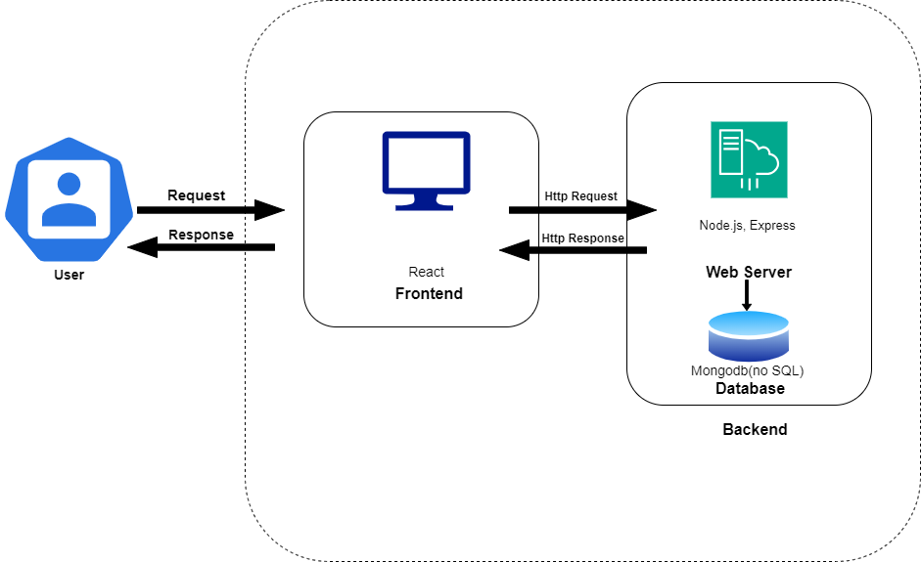

Figure 4.1 Basic Level Architectural Design

4.2.2 Detail Level Architectural Design

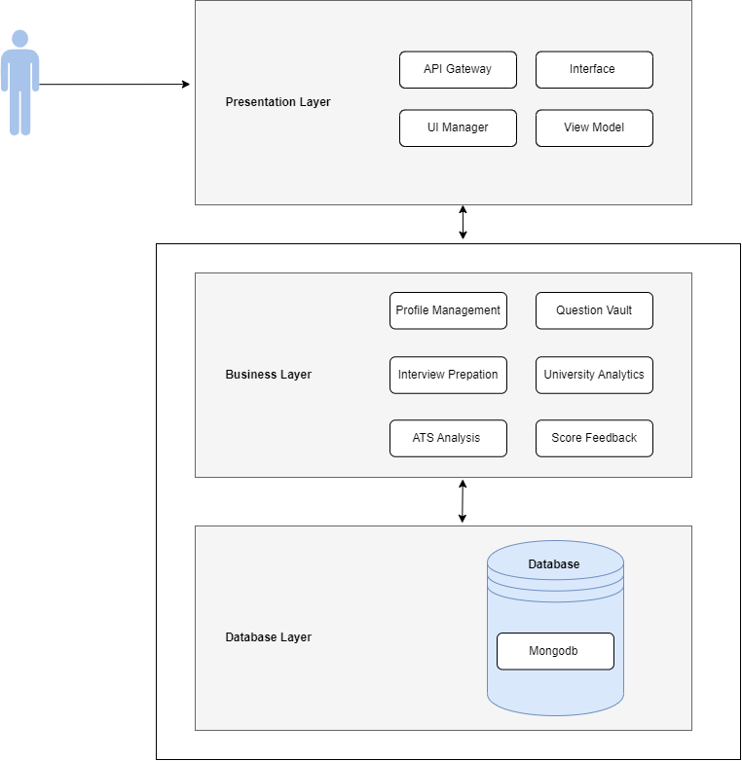
Figure 4.2 Level 1 Architectural Design Diagram

4.3 Detailed Design
Detailed design is the specification of the internal elements of all major system components, their properties, relationships, processing, and often their algorithms and data structures. During this phase, the system architecture is broken down into smaller components, and complex details about how these components will work and interact are defined. [3]
- Structural Diagrams
- Behavioral Diagrams

4.3.1 Structural Diagrams
Structural diagrams are an important part of the UML. It represents the static aspect of the system. These diagrams help illustrate different things and objects in the system being modeled and the static parts of the diagrams are represented by classes, interfaces, objects, components and nodes. These diagrams show the things and different objects in a system being modeled. [4]
The structural diagrams in this documentation are:
- Domain Diagram
- Deployment Diagram
- Data Model Diagram
- Component Diagram
- Jason Tree Diagram

4.3.1.1 Domian Diagram
In software engineering, a domain diagram is a type of static structure diagram that represents the conceptual structure of a system by illustrating the major entities or components within a specific domain, their key attributes, and the relationships among them. Unlike class diagrams, which focus on the technical aspects of a system's classes and their methods, a domain diagram provides a high-level view of the essential concepts and their interconnections, serving as a bridge between business requirements and technical design. It helps stakeholders understand how different parts of the system relate within the specific context of the domain. [5]
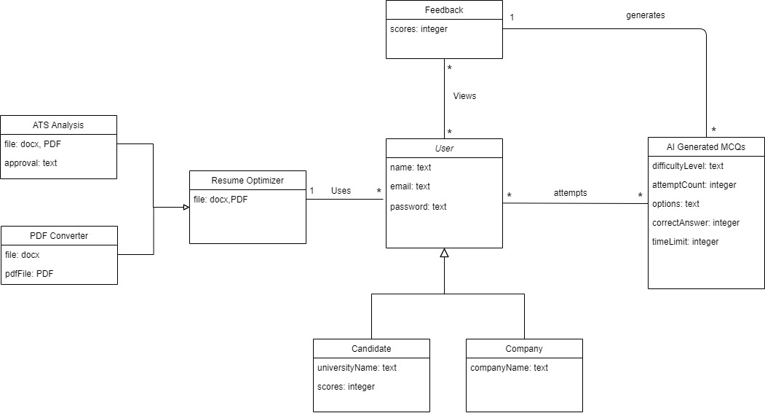
Figure 4.3 Domain Diagram

4.3.1.3 Deployment Diagram
A deployment diagram is a type of UML diagram that shows the execution architecture of a system, including nodes such as hardware or software execution environments, and the middleware that connects them. Deployment diagrams are commonly used to visualize the physical hardware and software of a system. Using deployment diagrams, one can gain insight into how the system will be physically implemented on the hardware. [7]
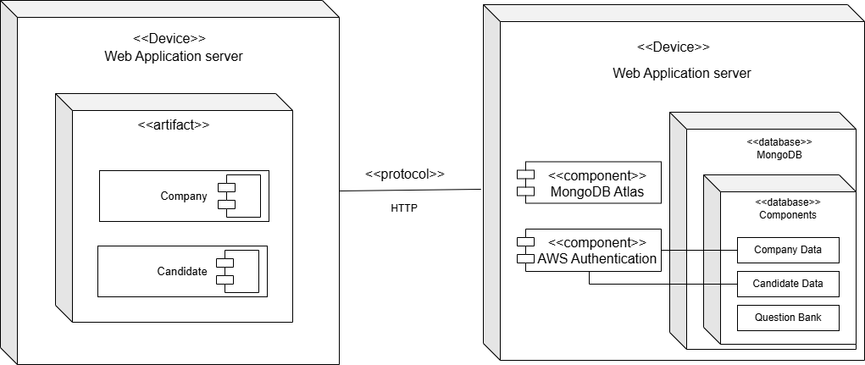
Figure 4.4 Deployment Diagram

4.3.1.4 JSON Tree Diagram
In software engineering, a is a type of static structure diagram that represents the hierarchical organization of data in a JSON (JavaScript Object Notation) format. It visualizes the relationships between parent and child nodes, the keys and values in objects, and the elements in arrays. Unlike class diagrams, which focus on the technical implementation of methods and classes, a JSON tree diagram provides a high-level structural view of the data, making it easier to understand how information is organized and nested. [8]

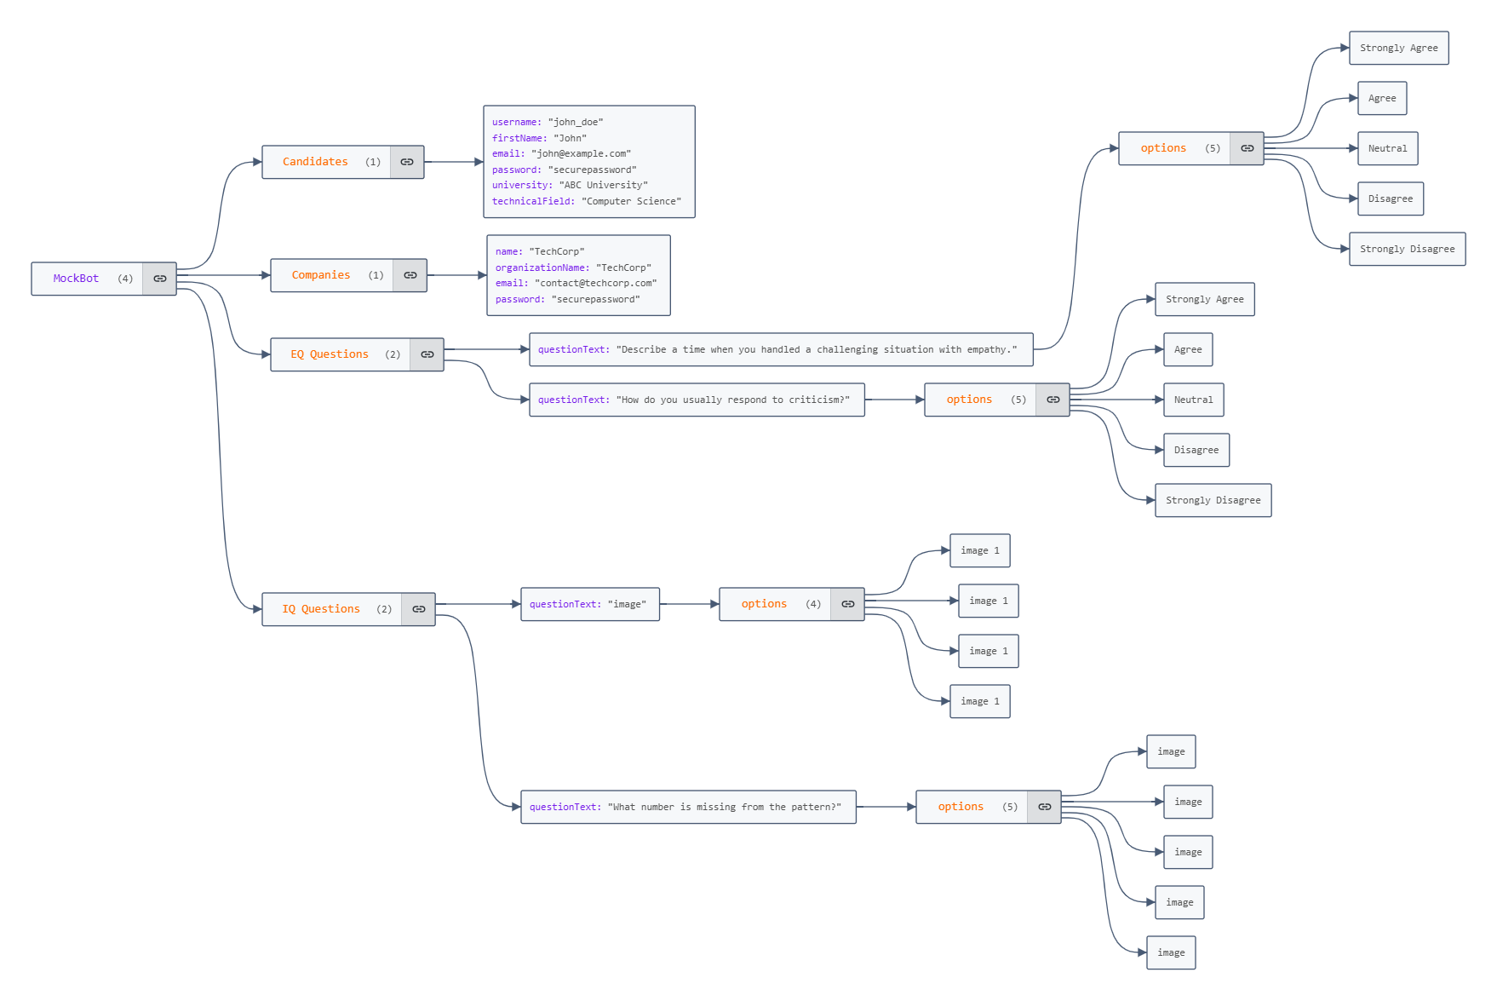

Figure 4.5 JSON Tree Diagram

4.3.1.5 Component Diagram
UML Component Diagrams show the structural relationships between the components of a system, illustrating how these components interact to form the system's architecture. In these diagrams, components represent modular parts of a system, such as executables, libraries, or databases, while the connections depict dependencies and interfaces that facilitate communication among them. We have designed component diagrams to show the organization of the system's physical components and their interactions, providing insight into /+the system's modular structure and deployment. [9]
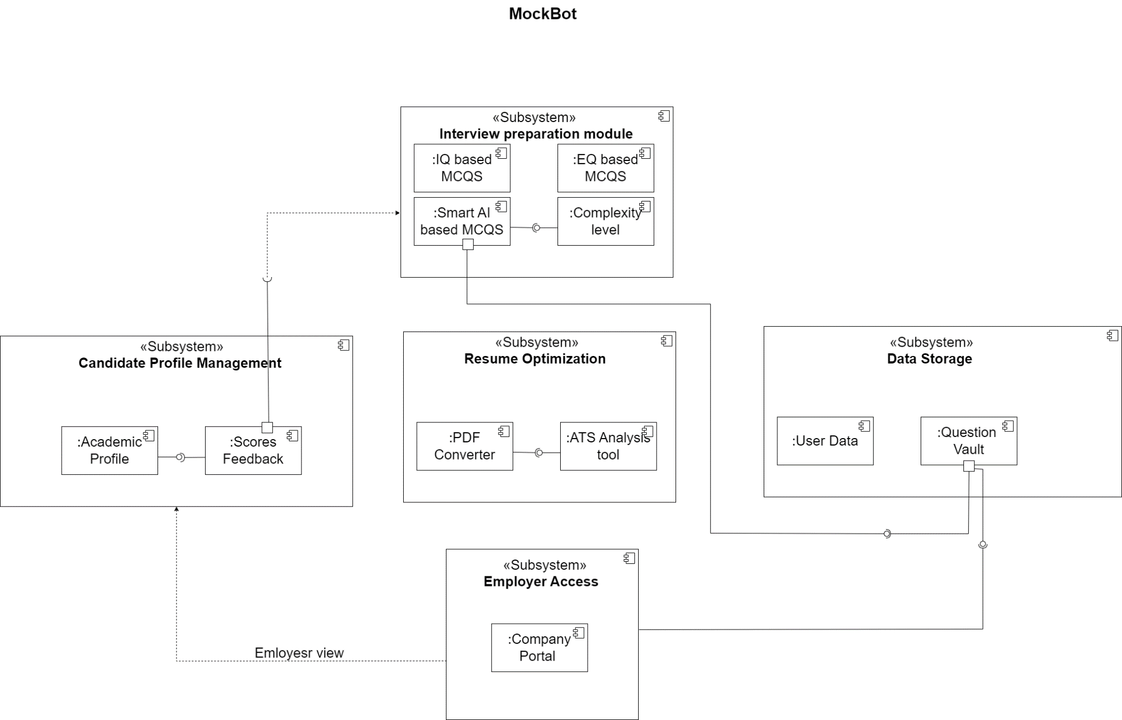
Figure 4.5 Component Diagram

4.3.2 Behavioral Diagram
UML Behavioral Diagrams show the components of a system that communicate the dynamic concepts of the system and their interrelationships. In these diagrams, the elements are comparable to verbs in a sentence, while the connections illustrate the sequence of events.[10] We have designed use case diagrams, sequence diagrams and activity diagrams to show the dynamic interaction of a system.

4.3.2.1 Use Case Diagram
Use case diagrams are considered for high level requirement analysis of a system. It is used to gather the requirements of a system including internal and external influences. The purpose of a use case diagram is to capture the dynamic aspect of a system. [11]
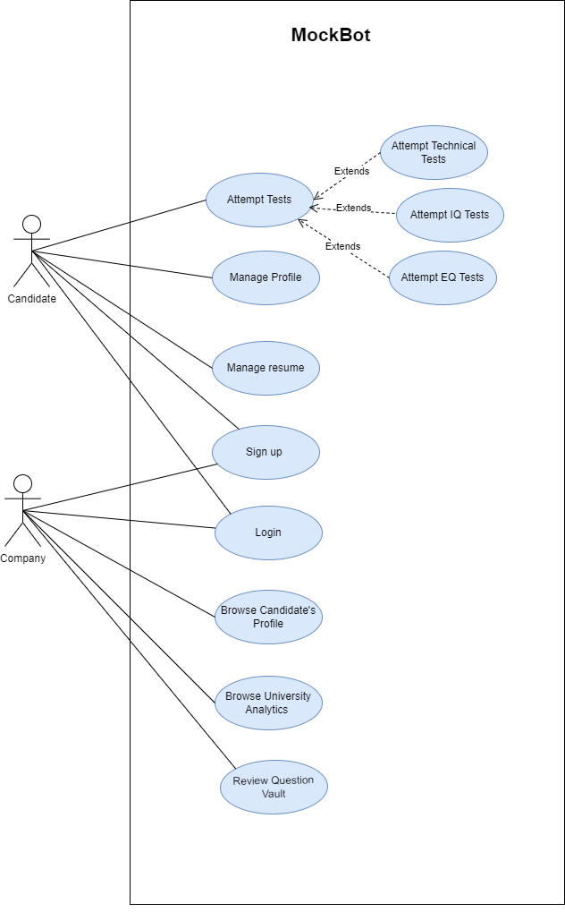
Figure 4.8 Use Case Design

4.3.2.2 System Sequence Diagram
A system sequence diagram (SSD) is a type of interaction diagram that illustrates the sequence of interactions between external actors and the system for a particular scenario or use case. SSDs focus on the system as a single entity and show the inputs and outputs exchanged between users (or other systems) and the system itself in a specific order. These diagrams are useful for capturing system requirements and understanding the flow of events, which helps in analyzing the system’s behavior and designing interactions for the new or existing processes. [12]
For details see Appendix A
4.3.2.3 Activity Diagram

Activity Diagrams are used to model sequence of actions as part of the process flow. It is used to model sequence of actions to capture the process flow actions and its results. It focuses on the work performed in the implementation of an operation (a method), and the activities in a use case instance or in an object. [13]
For details see Appendix B

Fully Dressed Use Cases
Use Case 1: Attempt Test
Section | Content
Scope | MockBot
Level | User level
Primary actor | Candidate
Stakeholders and interests | Candidates, Employers, Educational Institutes
Preconditions | The candidate is registered and logged into the MockBot system.The candidate has selected the test to attempt
Post conditions | The candidate answers are recorded and evaluated.The user receives a score and feedback on their performance.Test results are stored in the candidate's profile for future reference.Employers can view the user’s performance data through score analytics.
Main Success  Scenario | - Candidate logs into the MockBot system.  - System displays the dashboard.  - Candidate selects to the "Interview preparation" section.  - System displays available tests.  - Candidate selects a specific test to attempt.  - System displays test instructions and guidelines.  - Candidate reads the instructions and starts the test.  - System presents AI-generated or Standardized multiple-choice questions (MCQs).  - Candidate attempts the multiple choice questions within the allotted time.  - System records each answer and tracks the time.  - Candidate completes answering all multiple choice questions.  - System allows the candidate to submit the test.  - Candidate submits the test.  - System evaluates the answers, calculates the score and provides score feedback.  - System stores the scores in the candidate's profile.
Alternate flow | 8a. If the user encounters a technical issue during the test:  - The system saves the progress automatically.
Special Requirements | - The system should ensure test integrity and prevent cheating.  - The system should provide real-time feedback for incorrect answers after the test is submitted.  - The system should support concurrent test attempts by multiple users without performance degradation.  - The system should handle interruptions gracefully and allow users to resume tests.  - The system should provide clear instructions and error messages to guide users.
Technology and data  variations list | 1. React Js framework on the platform Visual Studio Code.
Frequency  of Occurrence | High
Open issues | - Ensuring the AI generates relevant and up-to-date questions.  - Ensuring the system is scalable to handle a large number of simultaneous test attempts.  - Implementing measures to maintain test security and prevent cheating.  - Ensuring effective communication of test results and feedback to users.

Use Case 2: Attempt technical test
Section | Content
Scope | MockBot
Level | User level
Primary actor | Candidate
Stakeholders and interests | Candidates, Employers, Educational Institutes
Preconditions | The candidate is registered, logged into the MockBot system, and has access to the "Attempt Test" section.  The candidate has selected a technical skill and a specific subject in which they want to be assessed.
Post conditions | The system records and evaluates all user responses.  The candidate receives a score and detailed feedback.  Test results are saved in the candidate’s profile.  Employers can access the candidate's performance data through score analytics based on privacy settings.
Main Success  Scenario | - Candidate selects "technical Mcqs" section.  - System provides a list of technical subjects(e.g., Data Structure, Mern Stack).  - Candidate selects a specific subject for the test.  - System displays test instructions, guidelines, and an initial  easy-level quiz for the subject.  - Candidate reads the instructions and begins the easy-level  test.  - System displays AI-generated, easy-level multiple-choice questions (MCQs) based on the selected subject.  - Candidate answers each question within the allotted time.  - System records each answer and tracks the time.  - Candidate submit the easy-Level test.  - System records the candidate test submission and checks it.  - Candidate pass the easy-level test.  - System generates a medium-level test in the same subject.  - Candidate attempts and submits the medium-level test  - System generates a high-level test in the same subject.  - Candidate attempts and submits the high-level test  - Upon completing the high-level test, the system  - evaluates the responses  - calculates the final score and provides score feedback across all levels.
Alternate flow | 12a. If the candidate does not pass the easy-level test  - The system generates a new easy-level test with different  questions, allowing the candidate to reattempt.  14a.If the candidate does not pass medium level  - The system generates a new easy-level test with different  questions, allowing the candidate to reattempt.  16a.If the candidate does not pass high level  - The system generates a new easy-level test with different questions, allowing the candidate to reattempt.
Special Requirements | - The system should ensure test integrity and prevent cheating.  - The system should provide real-time feedback on incorrect answers after test submission.  - The system must support concurrent test attempts by multiple users without performance degradation.  - The system should handle interruptions gracefully, allowing candidates to resume tests as needed.  - The system should offer clear instructions and error messages to guide candidates throughout the test.
Technology and data  variations list | 1.React Js framework on the platform Visual Studio Code.
Frequency  of Occurrence | High
Open issues | - Ensuring AI-generated questions are relevant, accurate, and up-to-date.  - Ensuring system scalability to handle high numbers of simultaneous test attempts.  - Maintaining test security and implementing effective anti-cheating measures.  - Ensuring clear and effective communication of test results and feedback to candidates.

Use Case 3: Attempt IQ Test
Section | Content
Scope | MockBot
Level | User level
Primary actor | Candidate
Stakeholders and interests | Candidates, Employers, Educational Institutes
Preconditions | The candidate is registered, logged into the MockBot system, and has access to the "Attempt IQ Test" section.  The IQ test format (12 picture-based questions, 4 response options) is set up within the system.
Post conditions | The candidate's responses are recorded, evaluated, and scored.  The system displays the candidate’s IQ score and feedback on performance.  The IQ test results are stored in the candidate’s profile for future reference.  Employers can view the candidate’s IQ performance data via analytics, depending on privacy settings
Main Success  Scenario | - The candidate selects the IQ test.  - The system displays test instructions and guidelines.  - The candidate reads the instructions and starts the IQ test.  - The system displays 12 picture-based multiple-choice questions one at a time, with each question having the following response options:  - Option A  - Option B  - Option C  - Option D  - Option E  - Option F  - The candidate selects a response for each of the 12 questions within the allotted time.  - The system records the selected response of the candidate and provide submit option.  - The candidate submits the IQ test.  - The system calculates the total IQ score based on each response.  - The system provides the IQ test score and feedback.
Alternate flow | 3a. Technical Issues Encountered:  - The system automatically saves the candidate’s progress.  - The candidate can resume the test once the issue is resolved.
Special Requirements | - The system should ensure test integrity and prevent tampering with responses.  - Support concurrent test attempts by multiple users without performance degradation.  - Gracefully handle interruptions, allowing candidates to resume tests as needed.  - Provide clear instructions, error messages, and feedback on performance.
Technology and data  variations list | 1. React Js framework on the platform Visual Studio Code.  2. Picture-based questions stored securely in the database.
Frequency  of Occurrence | High
Open issues | - Ensuring scalability for handling a large number of simultaneous IQ test attempts.  - Verifying that the scoring algorithm for IQ tests accurately assesses candidates' intelligence quotient.  - Secure and efficient communication of IQ results and feedback to candidates and employers.
Use Case 4: Attempt EQ Test
Section | Content
Scope | MockBot
Level | User level
Primary actor | Candidate
Stakeholders and interests | Candidates, Employers, Educational Institutes
Preconditions | The candidate is registered, logged into the MockBot system, and has access to the "Attempt EQ Test" section.  The EQ test format (33 questions, 4 response options) is set up within the system.
Post conditions | The candidate’s responses are recorded, evaluated, and scored based on their choices.  The system displays the candidate’s EQ score and feedback on their performance.  The EQ test results are stored in the candidate’s profile for future reference.  Employers can view the candidate’s EQ performance data through analytics, depending on privacy settings.
Main Success  Scenario | - Candidate selects the EQ test.  - system displays test instructions, guidelines.  - Candidate reads the instructions and Start the EQ test.  - System display 33 multiple choice questions, one at a time, with each  question having the following response options:  1 = Strongly Disagree  2 = Disagree  3 = Agree  4 = Strongly Agree  - Candidate selects a response for each 33 questions within allotted time.  - System Records the selected option, assigns a rank score to the response (1, 2, 3, or 4), and moves to the next question.  - System confirms that all questions are answered and  displays an option to submit the test.  - Candidate submits the EQ test.  - System calculates the total EQ score based on the ranked  values of each response.  - System provides EQ test scores.
Alternate flow | 3a. If the candidate encounters a technical issue during the EQ test  - System saves the candidate’s progress automatically and allows them to resume the test when the issue is resolved.
Special Requirements | - The system should ensure test integrity and prevent tampering with responses.  - The system should support concurrent test attempts by multiple users without performance degradation.  - The system should handle interruptions gracefully, allowing candidates to resume tests as needed.  - The system should provide clear instructions, error messages,and feedback on performance.
Technology and data  variations list | 1.React Js framework on the platform Visual Studio Code.
Frequency  of Occurrence | High
Open issues | - Ensuring the system is scalable to handle a large number of simultaneous EQ test attempts.  - Confirming that the scoring algorithm for EQ tests accurately represents candidates' emotional intelligence.  - Implementing secure and effective communication of EQ results and feedback to candidates and employers.

Use Case 5: Manage Profile
Section | Content
Scope | MockBot
Level | User level
Primary actor | Candidate
Stakeholders and interests | Candidates, Employers, Educational Institutes
Preconditions | The Candidate is registered and logged into the MockBot system.
Post conditions | The Candidate's updated profile information is saved and viewable by authorized parties based on privacy settings.
Main Success  Scenario | - Candidate select on the profile area in the dashboard.  - System navigates to and displays the Profile section with current profile information fields.  - Candidate selects edit option.  - System enables the profile fields for editing, allowing the candidate to modify their information  - Candidate edit their name, university name, first name, subject and email in the fields.  - System validates the input for accuracy and completeness.  - Candidate select save option.  - System successfully saves the updated profile information.
Alternate flow | 7a. If the candidate leaves required fields empty:  - System displays an error message prompting the user to complete all required fields.  - Candidate fills in the missing information and resubmits.
Special Requirements | - System should ensure data security and privacy, with profile visibility controlled by the user’s privacy settings.  - System should provide confirmation messages for successful updates.  - System should prevent unauthorized users from accessing or modifying profile information.
Technology and data  variations list | 1.React Js framework on the platform Visual Studio Code.
Frequency  of Occurrence | Medium
Open issues | - Ensuring data is consistently synchronized across different access points (web and mobile).  - Developing secure access control to protect user profile data from unauthorized access.  - Ensuring clear and understandable error messages during profile updates.

Use Case 6: Manage resume
Section | Content
Scope | MockBot
Level | User level
Primary actor | Authorized User (Company or University Institute)
Stakeholders and interests | Candidates, Employers, Educational Institutes
Preconditions | The candidate is logged into the MockBot system.  The candidate has a resume prepared for upload.  The candidate has a resume document in an accepted format (e.g., .docx).
Post conditions | The candidate can successfully upload, convert, download, and analyze their resume.  The candidate receives feedback on the resume's ATS compatibility.
Main Success  Scenario | - Candidate logs into the MockBot system.  - System displays the dashboard containing "Resume Optimization" section with two primary options:  - Option 1: PDF Conversion  - Option 2: ATS Analysis  Flow A: PDF Conversion:  - Candidate selects the option to upload a resume.  - System prompts candidate to upload a resume file in docx format .  - Candidate uploads the resume file.  - System verifies the file format and size and confirms  successful upload.  - Candidate selects the submit button to convert the resume to PDF.  - System converts the resume to PDF format and display download link.  - Candidate downloads the PDF version of the resume.  Flow B: ATS Analysis  - Candidate selects the ATS Analysis option.  - System Displays a file upload prompt, asking the candidate  to upload a resume in an accepted format.  - Candidate uploads the resume file.  - System analyzes the resume for ATS compatibility and  display ATS result of "Accepted"
Alternate flow | 3a.If the uploaded resume file is in an unsupported format or exceeds the allowed size:  - System displays an error message prompting the candidate to upload a file in the correct format or size.  6a: If the resume is not ATS compatible:  - System displays message of "Rejected".
Special Requirements | - The system should analyze the resume against commonly used ATS criteria (e.g., keyword presence, formatting, and file structure) to determine if it would be accepted or rejected.  - Resume data should be securely stored, and access should be controlled to ensure candidate privacy.  - The system must provide a reliable conversion mechanism to generate PDF files from different formats.  - The interface should be intuitive, with clear instructions for each step (uploading, converting, downloading, analyzing).
Technology and data  variations list | 1.React Js framework on the platform Visual Studio Code.
Frequency  of Occurrence | High
Open issues | - Ensuring all resume data complies with data privacy regulations and is stored securely.  - Ensuring that ATS analysis is accurate across different ATS systems, as each may have unique requirements.  - Guaranteeing that the PDF conversion retains the resume's formatting accurately.  - Providing clear, actionable feedback in ATS analysis to help candidates optimize their resumes effectively.
Use Case 7: SignUp
Section | Content
Scope | MockBot
Level | User level
Primary actor | Candidate
Stakeholders and interests | Candidates, Employers, Educational Institutes
Preconditions | The user does not have an existing MockBot account and has access to the Login page.
Post conditions | The user's account is created with appropriate role-based access. The user is redirected to the role-specific dashboard, ready to explore relevant features.
Main Success  Scenario | - User selects their role(Company, Candidate).  - System displays the sign-up form specific to the selected role, including fields for required information:  - For Candidates: Name, Email, Password, Confirm Password  - For Companies: Company Name, Contact Person, Email, Password.  - User enters their information and sets a password.  - System validates the provided information for completeness and password strength.  - User select signup.  - System display the user to the respective dashboard:  - Candidate Dashboard for candidates.  - Company Dashboard for employers.
Alternate flow | 3a. If the User enters incomplete or invalid information:  - System displays an error message indicating missing or incorrect fields.  - User corrects the information and resubmits.
Special Requirements | - System should use encryption to securely handle passwords and sensitive information.  - System should provide clear guidance on password requirements and error messages for invalid entries.
Technology and data  variations list | 1. React Js framework on the platform Visual Studio Code.
Frequency  of Occurrence | Low
Open issues | - Ensuring secure handling of sensitive registration data.  - Preventing duplicate account creation for the same email.  - Providing user support in case of issues with verification.

Use Case 8: Login
Section | Content
Scope | MockBot
Level | User level
Primary actor | Candidate
Stakeholders and interests | Candidates, Employers, Educational Institutes
Preconditions | The user has an existing MockBot account and access to the Login page.
Post conditions | The user is authenticated successfully and redirected to their role-specific dashboard.
Main Success  Scenario | - User selects their role(Candidate, Company)  - System displays the login form specific to the selected role, including fields for required information:  For Candidates: Email, Password  For Companies: Email, Password  - User enters their details(email,password)and select login.  - System validates the provided credentials against stored records.  - If the credentials are correct:  System authenticates the user.  System display the user to their role-specific dashboard:  - Candidate Dashboard for candidates.  - Company Dashboard for employers.
Alternate flow | 3a. If the user enters invalid or incomplete information:  - System displays an error message indicating missing or incorrect fields.  - User corrects the information and resubmits.  4a. If the credentials are incorrect:  - System displays an error message indicating invalid email or password.  - User can re-enter their credentials or use the "Forgot Password" option to reset their password.
Special Requirements | - The system should securely handle passwords and sensitive information using encryption.  - Authentication should involve secure session handling to prevent unauthorized access.  - The system should ensure that appropriate error messages are displayed for incorrect credentials.
Technology and data  variations list | 1. React Js framework on the platform Visual Studio Code.
Frequency  of Occurrence | Low
Open issues | - The system should securely handle passwords and sensitive information using encryption.  - Authentication should involve secure session handling to prevent unauthorized access.  - The system should ensure that appropriate error messages are displayed for incorrect credentials.

Use Case 9: browse candidates profile
Section | Content
Scope | MockBot
Level | User level
Primary actor | Authorized User (Company or University Institute)
Stakeholders and interests | Candidates, Employers, Educational Institutes
Preconditions | The company is logged into the MockBot system.  The candidate has a public profile, or specific profile sections have been shared with authorized users based on privacy settings.
Post conditions | The Company can view the candidate's profile information, including education, skills, and performance data, based on the candidate’s privacy settings.
Main Success  Scenario | - Company browse available profiles.  - System displays a list of candidate profiles detail and performance score in test.  - Company review the performance of candidate.  - System show highest rank candidate.  - Company select on the candidate's email address they wish to contact  - System redirects the company to the Gmail compose message page
Alternate flow | 5a.If the company decides not to contact the candidate via email,  - System provides a "Back to Candidate List" option, allowing the company to continue browsing or search for another candidate.  5b.If there is a technical issue or the system cannot redirect to Gmail (e.g., Gmail is not set as the default email client),  - System displays an error message like "Unable to open email client. Please manually compose an email or use your preferred email client."
Special Requirements | - The system should enforce privacy settings to restrict access to candidate information based on their configured preferences.  - The system should display only relevant and allowed sections of the candidate’s profile to ensure data security.  - The interface should provide a clear, organized layout for easy viewing of candidate information.
Technology and data  variations list | 1.React Js framework on the platform Visual Studio Code.
Frequency  of Occurrence | High
Open issues | - Ensuring compliance with data privacy laws, especially when sharing sensitive candidate data with third-party companies.  - Defining clear privacy settings and notifications for candidates when their profile is viewed by authorized users.  - Implementing access request workflows in cases where users need to request profile access from candidates.

Use Case 10: Browse University Analytics
Section | Content
Scope | MockBot
Level | User level
Primary actor | Company
Stakeholders and interests | Candidates, Employers, Educational Institutes
Preconditions | The company is logged into the MockBot system.  University ranking data is available in the system.  The company has been granted access to view the university rankings and student performance analytics.
Post conditions | The company can view a list of universities ranked based on student performance in MockBot assessments.  The company can click on a university to view a list of its students and their scores.  The company can filter students based on performance metrics (e.g., highest scores, average scores, etc.).
Main Success  Scenario | - Company logs into the MockBot system.  - The system displays the company dashboard with an option to access the University Rankings section.  - Company selects the "University Rankings" option.  - The system displays a list of universities ranked by candidate performance in MockBot test.  - Company reviews candidate performance.  - System allows the company to review filter rank of student bases on their performance matrix.
Alternate flow | 3a. If the system fails to retrieve student data:  - The system displays an error message indicating that student data could not be retrieved.  - The company can either retry or contact MockBot support for assistance.
Special Requirements | - The system must enforce permissions so that only authorized users (companies) can access university rankings and student performance data.  - The system should clearly distinguish universities with top-ranked students.  - The interface should allow for easy navigation between university rankings and individual student profiles.
Technology and data  variations list | 1. React Js framework on the platform Visual Studio Code.
Frequency  of Occurrence | High
Open issues | - The system needs to ensure that sensitive student performance data is shared in compliance with data privacy regulations when shared with third-party companies.  - Implementing a system to automatically notify administrators if there are any changes in university rankings or new student performance data.  - Determining which data can be shown to companies and how deep into the student performance data they can go (e.g., whether detailed feedback from assessments is visible).

Use Case 11:Review Question Vault
Section | Content
Scope | MockBot
Level | User level
Primary actor | Company
Stakeholders and interests | Candidates, Employers, Educational Institutes
Preconditions | The company is logged into the MockBot system.  The AI-generated questions for candidate tests are available in the Question Vault.  The company has been granted access to review AI-generated questions.
Post conditions | The company can view AI-generated questions and provide feedback if they don’t meet the company’s standards.  The feedback is sent via email to MockBot administrators or the relevant team for further review and adjustments.
Main Success  Scenario | - Company select on the "Question Vault."  - System displays a list of generated questions created for candidate tests.  - Company reviews the displayed questions and uses the search functionality to look for a specific keyword.  - System filters and displays questions containing the searched keyword.
Alternate flow | 3a.If the question does not meet company standards:  - the company has the option to report it to the MockBot system team via email.  - System note the report for improvement in the questions to change.
Special Requirements | - The interface should clearly distinguish approved and unapproved questions in the Question Vault for easy tracking.  - Feedback submissions should be securely sent via email and logged in the system for reference.  - The system should allow companies to filter questions by topic.
Technology and data  variations list | 1.React Js framework on the platform Visual Studio Code.
Frequency  of Occurrence | High
Open issues | - Ensuring compliance with data privacy laws when sharing generated questions with third-party companies.  - Establishing a response process for feedback to ensure timely adjustments to questions that do not meet standards.  - Implementing automated notifications to administrators for follow-up actions on questions flagged with feedback.

Chapter 5:

Implementation

Chapter 5: Implementation

5.1 Endeavour (Team + Work + Way of Working)
5.1.1 Team
- Maryam Malik
- Musabbiha Zahid
- Mahnoor Tanzeel Satti

5.1.2 Work
- Planning
- Requirement Gathering
- Designing
- Implementation
- Testing

5.1.3 Way of working
In every part of the Software Development Life Cycle or SDLC, there are different things we do to make sure the project goes well. We're going to describe what we do in each part of the process and how everyone in the team works together to make it happen.
5.1.3.1 Planning

Planning | Implemented by
Develop Plan | Maryam Malik
Design Plan | Musabbiha Zahid
Review Plan | Mahnoor Tanzeel Satti
Table 3 Planning

5.1.3.2 Requirements Gathering

Requirements Gathering | Implemented by
Elicit and document requirements | Maryam Malik, Musabbiha Zahid, Mahnoor Tanzeel Satti
literature review | Musabbiha Zahid
Market survey | Mahnoor Tanzeel

Table 4 Requirements Gathering

5.1.3.3 Designing
Designing | Designed by
Basic level Architecture, Deployment  Diagram, Sequence diagram, State diagram | Maryam Malik
Data Model,System Sequence diagram, State diagram,Component diagram | Mahnoor Tanzeel Satti
Use Case  Diagram,System Sequence diagram, State diagram | Musabbiha Zahid

Table 5 Designing

5.1.3.4 Implementation

Implementation | Implemented by
Company Panel | Musabbiha Zahid, Maryam Malik
Company Panel | Mahnoor Tanzeel Satti, Musabbiha Zahid

Table 6 Implementation

5.1.3.5 Testing

Testing | Implemented by
Build Scenarios, Test cases | Maryam Malik
Build Scenarios, Test cases | Musabbiha Zahid
Build Scenarios, Test cases | Mahnoor Tanzeel Satti

Table 7 Testing

5.2 Flow Control/Pseudo codes
A flowchart is a visual representation of a series of steps, presenting them in a sequential order. It is widely used in presenting the flow of algorithms, workflow or processes. Typically, a flowchart shows the steps as various types of boxes, and their sequence is indicated by connecting them with arrows. [13]

5.3 Components, Libraries, Web Services, and Stubs

Components and libraries are sets of pre-made, tested, and well-documented UI components that can be easily reused by integrating them across the user interface of a system.

5.3.1 Frameworks

- React Js
- React Router

5.3.2 Web Libraries/ API’s Components

- Font awesome
- React
- React-dom
- React-icons
- React-router-dom
- React-scripts
- Rest API
- Cors
- Axios
- Dotenv
- Express
- Form-data
- Fs
- Mongoose
- Multer

5.3.3 External Libraries/ API’s / Services

- Convert API
- Google Sign-In for Web Application
5.3.4 Languages

- JavaScript (JSX)
- HTML
- CSS

5.3.5 Platforms/ Tools

To develop the system, following tools are used by the team members:
- Visual Studio Code
- GitHub
- Draw.io
- MongoDBCompass
- Google Meet
- Google Docs
- Microsoft Word
- Microsoft PowerPoint
- Google Form
- Draw.io
- MongoDBCompass
- Gmail

5.4 Best Practices / Coding Standards

5.4.1 React:
- Organize components logically
- Add reusable components in one file
- Create pages and use components in them
- Utilize hooks like useState and useEffect
- Use consistent and meaningful names
- Enhance code readability
- Implement responsive components

5.4.2 Node.js and Express:

- Modular code structure (controller, routes, server)
- Asynchronous programming
- Middleware separation
- Environment variables in dotenv file
- Error Handling
5.4.3 MongoDB (database):

- Schema Design Using mongoose
- Handle Database Connection

5.5 Deployment Environment

The "MockBot" is a web application designed to promote mutual understanding between candidates and companies. Through this innovative platform, companies actively engage in evaluating candidates' growth and development, enhancing the hiring experience. An active internet connection is necessary to use this web app, which is open to anyone interested in monitoring candidate performance and interview preparation. The flow of data within the system begins on the client side, where users interact with the web app interface. After users interact with the web app, the information is sent to the server where it is processed and stored in a database.
5.5.1 Hardware Requirements:

System | Requirement
Laptop / Desktop | Windows, Mac
RAM | 4 GB
Hard Drive | 10 GB
Browser | Chrome, Safari, Microsoft Edge, Firefox

Table 8 Hardware Requirements

5.5.2 Software Requirements:

Software | Requirement
Integrated Development Environment | Visual Studio Code
Application Programming Interface | Rest API
Programming languages | React Js
Database | No SQL (MongoDB)
Developer Tool | React DevTools
Version Control System | Git, Github

Table 9 Software Requirements

5.6 Summary
In Chapter 5, we describe how the team works together and breaks down tasks during the different stages of creating the software. The team, which includes Maryam Malik, Musabbiha Zahid, and Mahnoor Tanzeel, handles tasks like planning, gathering requirements, designing, implementation, and testing. Each person in the team has specific roles during each of these phases. The chapter also includes flow charts that explain how processes flow through the Candidate, Company, and Admin parts of the project. Additionally, we describe the tools and building blocks used, such as React for the frontend, Node.js and Express for the backend, and MongoDB for the database, following the MERN stack approach. The chapter also covers coding standards and best practices to ensure quality. Finally, it discusses how and where the software will be used, including the devices and systems needed to run it. Overall, it provides a clear picture of how the team collaborates to develop the "MockBot" web application.

Chapter 6:

Testing and Evaluation

Chapter 6: Testing and Evaluation

6.1 Introduction
Scenario based black box testing technique is used for testing core system functionality.
All scenarios are generated from the system use case diagram.

6.2 List of test scenarios
The lists of test scenarios considered for the project are:
See Appendix C: Testing

6.3 Performance and evaluation
The test cases are formulated to detect any anomalies in the customary or anticipated progression of the system. The test cases are validated, and the factual outcome corresponds to the projected outcome of the system.

Appendix A:

System Sequence Diagram

Appendix A: System Sequence Diagram:
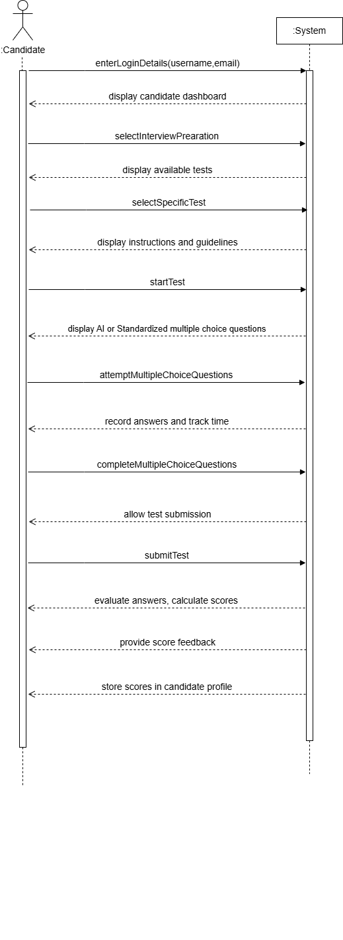
- Attempt Test
Figure 4.8 Attempt Test
- Attempt Technical test
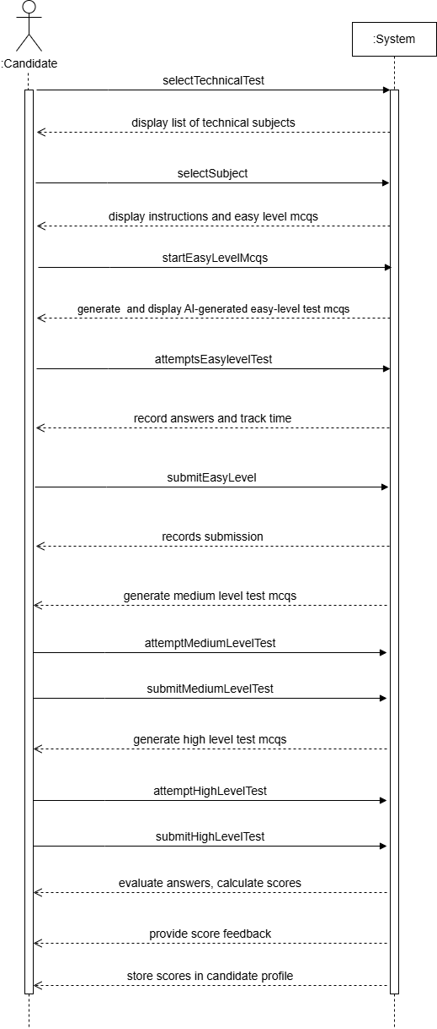

Figure 4.9 Attempt Technical Test

- Attempt IQ test
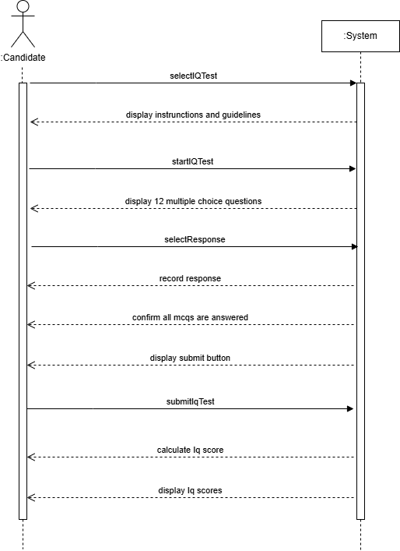

Figure 4.10 Attempt IQ Test

- Attempt EQ test
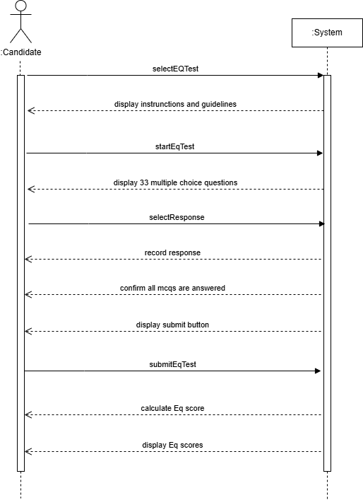

Figure 4.11 Attempt EQ Test

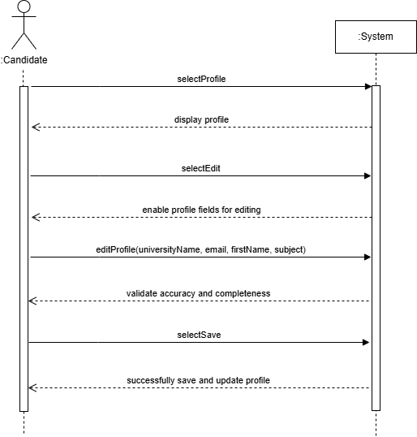
- Manage Profile

Figure 4.12 Manage Profile

- Manage Resume
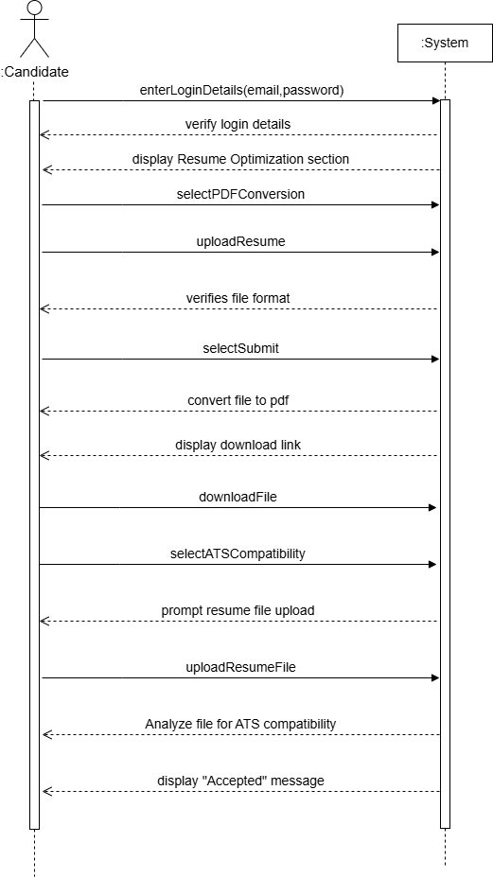
Figure 4.13 Manage Resume

- Login
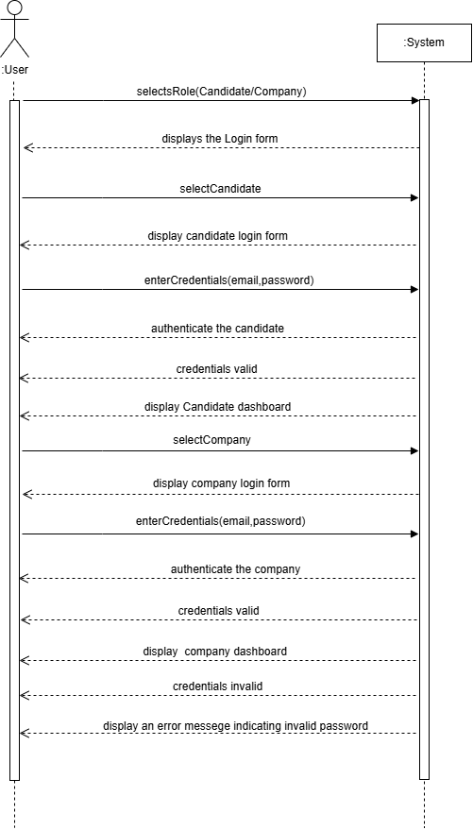
Figure 4.14 Login

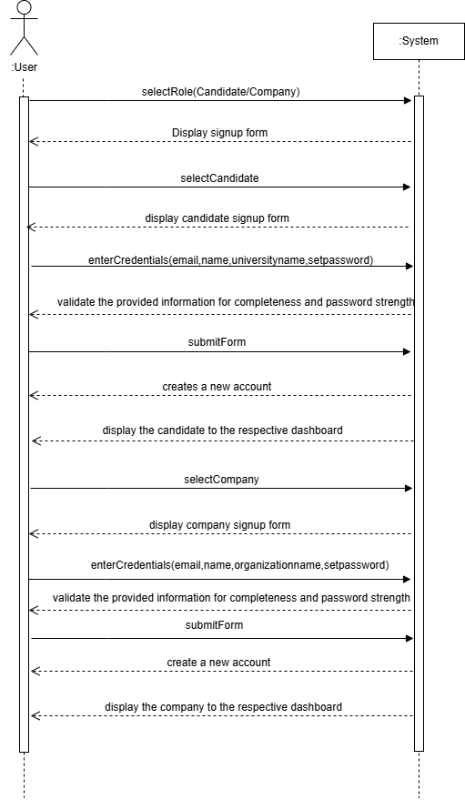
- Signup

Figure 4.15 Signup

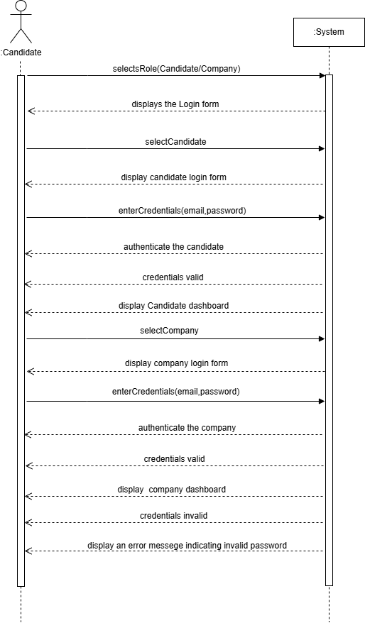
- Browse Candidate Profile

Figure 4.16 Browse Candidate Profile

- Browse University Analytics

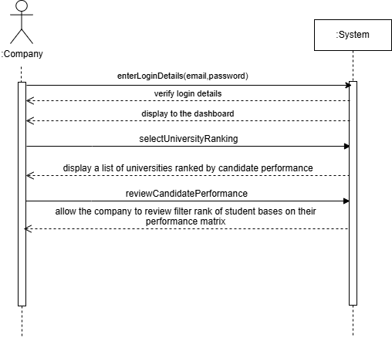

Figure 4.17 Browse University Analytics

- Question Vault

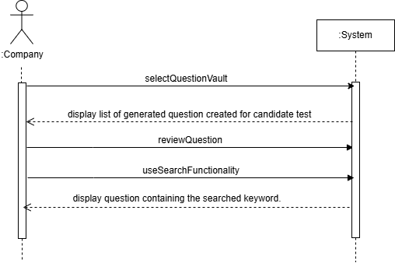

Figure 4.17 Question Vault

Appendix B:

ActivityDiagram

Appendix B: Activity Diagram
- Attempt Test

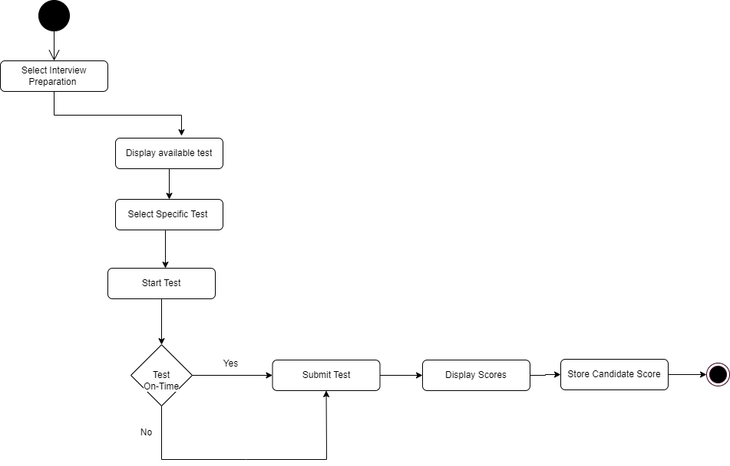
Figure 4.19 Attempt Test

- Attempt Technical Test
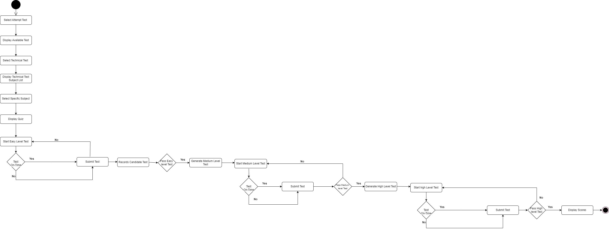

Figure 4.20 Attempt Technical Test

- Attempt IQ Test:

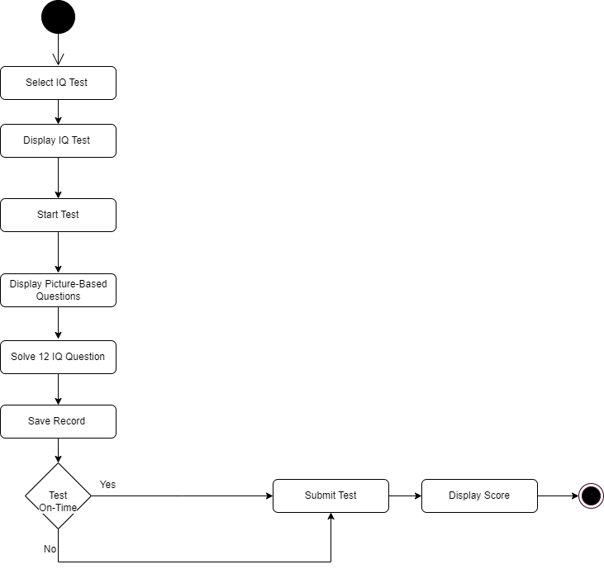

Figure 4.21 Attempt Technical Test

- Attempt EQ Test

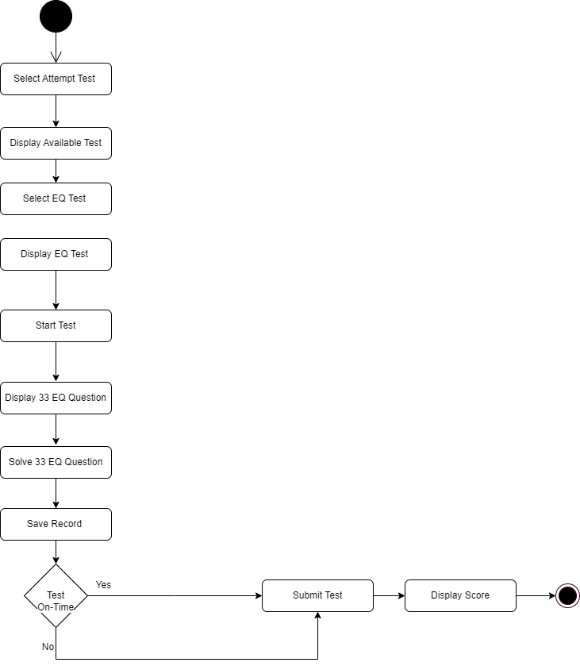

Figure 4.22 Attempt EQTest

- Manage Profile
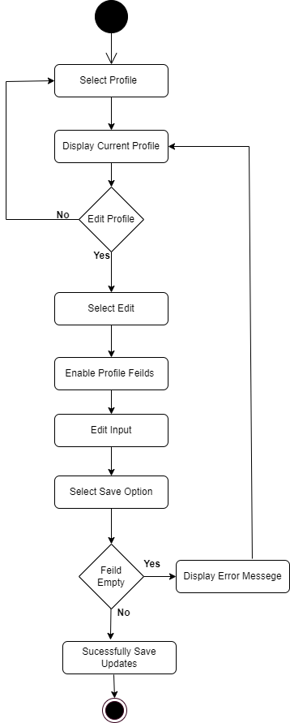

Figure 4.23 Manage Profile

- Manage Resume
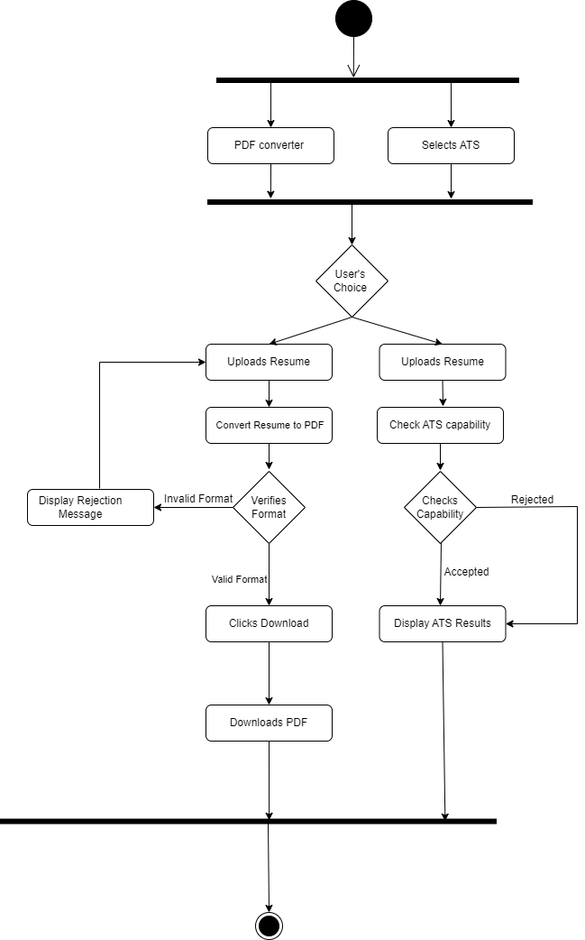

Figure 4.24 Manage Resume

- Signup
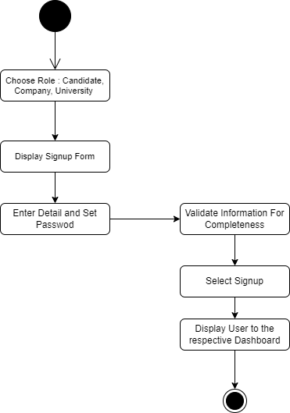

Figure 4.25 Sign up

- Login
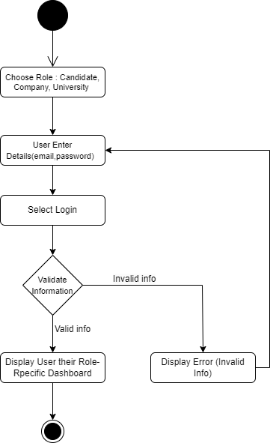

Figure 4.26 Login

- Browse Candidate Profile

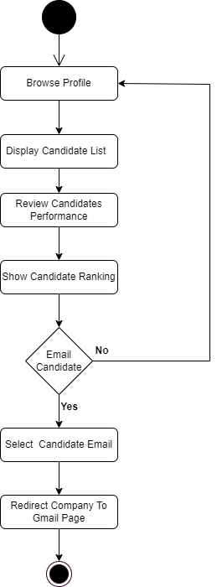

Figure 4.27 Browse Candidate Profile

- Browse University Analytics:

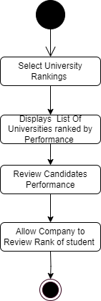

Figure 4.28 Browse University Analytics

- Review Question Vault


Figure 4.29 Review Question Vault

Appenix C:

Test Scenarios

Appendix C: Test Scenario
Test Cases:
Test Case 01:
Test Case ID | Test Scenario | Test Steps | Test Data | Expected Results
TC 1 | Verify that the candidate can access the PDF conversion tool from the resume submission interface. | Log in as a candidate.  Navigate to the resume submission interface.  Click the "Convert to PDF" button.  Verify if the PDF conversion tool is accessible. | Candidate's resume submission page. | The candidate should be able to access the PDF conversion tool from the resume submission interface.
TC 2 | Verify that the system accepts valid resume formats such as DOCX. | Log in as a candidate.  Navigate to the resume submission interface.  Upload a valid resume format (e.g., DOCX).  Click the "Convert to PDF" button. | Resume file: resume.docx | The resume should be accepted for conversion to PDF.
TC 3 | Verify that the system rejects invalid resume formats such as EXE, JPG, PNG, GIF, HTML, MP4, ZIP. | Log in as a candidate.  Navigate to the resume submission interface.  Upload an invalid resume format (e.g., JPG, EXE).  Click the "Convert to PDF" button. | Resume file: image.jpg | . The system should reject the invalid file and show an error message such as "Unsupported file format."
TC 4 | Verify that the system converts a valid resume (e.g., DOCX) to PDF while preserving the layout and formatting failing (ECP - valid upload) | Log in as a candidate.  Upload a valid resume file (e.g., DOCX).  Click the "Convert to PDF" button.  Verify that the resume is converted to PDF without losing layout or formatting. | Resume file: resume.docx | The resume should be successfully converted to PDF while preserving its layout and formatting.
TC 5 | Verify that the system fails to preserve the layout and formatting during the conversion of a valid resume file to PDF. | Log in as a candidate.  Navigate to the resume submission interface.  Upload a valid resume file (e.g., DOCX) with complex formatting (e.g., tables, bullet points, images).  Click the "Convert to PDF" button.  Compare the layout and formatting of the original file with the converted PDF. | Resume file: complex_resume.docx  Contains elements such as:  Tables  Bullet points  Embedded images  Multi-level headings | The PDF should display a warning or error message indicating that the layout and formatting were not preserved correctly.

Table: Resume PDF Converter

Test Case 02:
Test Case ID | Test Scenario | Test Steps | Test Data | Expected Results
TC-1 | Verify that the profile section displays current user information. | 1. Login as a candidate.  2. Navigate to the Profile section. | Name: "John Doe"  Email: "john.doe@example.com" | The Profile section displays all current fields, including name, university name, subject, and email.
TC-2 | Verify the "Edit" option enables profile fields for editing. | 1. Navigate to the Profile section.  2. Click the "Edit" option. | N/A | The system enables all fields (name, university name, subject, and email) for editing.
TC-3 | Verify that a valid email is accepted during profile update. | 1. Navigate to the Profile section.  2. Click "Edit".  3. Update the email field with a valid email.  4. Click "Save". | Email: "alice@example.com" | The profile updates successfully, and a confirmation message "Profile updated successfully" is displayed.
TC-4 | Verify that an invalid email is not accepted during profile update. | 1. Navigate to the Profile section.  2. Click "Edit".  3. Update the email field with an invalid email.  4. Click "Save". | Email: "alice.example.com" | The system does not save the profile and displays an error message: "Invalid email format."
TC-5 | Verify that incomplete profile fields cannot be saved. | 1. Navigate to the Profile section.  2. Click "Edit".  3. Clear the "Name" field.  4. Click "Save". | Name: (empty) | The system does not save the profile and displays an error message: "All required fields must be completed."
TC-6 | Verify unauthorized access to the Profile section is restricted. | 1. Open the application as an unauthenticated user.  2. Attempt to navigate to the Profile section. | N/A | The system denies access and displays an error message: "You must be logged in to view this section."
TC-7 | Verify that the system displays a success message after saving valid profile updates. | 1. Navigate to the Profile section.  2. Click "Edit".  3. Update all fields with valid data.  4. Click "Save". | Name: "Alice Smith"  Email: "alice@example.com" | The profile updates successfully, and a confirmation message "Profile updated successfully" is displayed.
TC-8 | Verify that unauthorized edits to the profile fields are not allowed for non-logged-in users. | 1. Open the application as an unauthenticated user.  2. Attempt to edit profile fields. | N/A | The system restricts editing and displays an error message: "Unauthorized access."
TC-9 | Verify saving profile updates when all required fields are completed correctly. | 1. Navigate to the Profile section.  2. Click "Edit".  3. Fill in all fields correctly.  4. Click "Save". | Name: "John Doe"  University: "ABC University"  Subject: "Computer Science"  Email: "john@example.com" | The profile updates successfully, and a confirmation message "Profile updated successfully" is displayed.
TC-10 | Verify system validation rejects invalid characters in name fields. | 1. Navigate to the Profile section.  2. Click "Edit".  3. Update the "Name" field with invalid characters (e.g., "@").  4. Click "Save". | Name: "John@Doe" | The system does not save the profile and displays an error message: "Invalid characters in the Name field."

Table: Candidate Profile

Test Case 03:
Test Case ID | Test Scenario | Test Steps | Test Data | Expected Results
TC-1 | Verify centralized repository stores all question types | - Access the repository.  - Check for all question types (Technical, EQ, IQ). | Repository with all question types | Repository contains all question types and displays them correctly.
TC-2 | Verify repository missing a question type | - Access the repository.  - Check for missing question types. | Repository missing EQ questions | System displays an error: "Repository incomplete, missing EQ questions."
TC-3 | Verify difficulty-level categorization: Valid | - Access the repository.  - Check questions categorized as Easy, Medium, Hard. | Difficulty levels: Easy, Medium, Hard | System displays questions grouped correctly by difficulty level.
TC-4 | Verify difficulty-level categorization: Invalid | - Access the repository.  - Check for missing or miscategorized difficulty levels. | Difficulty levels: None | System displays an error: "Difficulty-level categorization incomplete."
TC-5 | Verify subject-specific categorization: Valid | - Access the repository.  - Check questions categorized as Database, Computer Science. | Subjects: Database, CS | System displays questions grouped by subject.
TC-6 | Verify subject-specific categorization: Invalid | - Access the repository.  - Check for missing or misclassified subjects. | Subjects: None | System displays an error: "Subject categorization incomplete."
TC-7 | Verify valid keyword filtering | - Use the search functionality.  - Enter a valid keyword. | Search keyword: "Database" | System displays questions matching the keyword "Database."
TC-8 | Verify invalid keyword filtering | - Use the search functionality.  - Enter an invalid keyword. | Search keyword: "XYZ123" | System displays "No questions found for the keyword."
TC-9 | Verify all stored questions are visible | - Access the repository.  - Check if all stored questions are displayed. | Repository with 100 questions | System displays all 100 stored questions.
TC-10 | Verify question display fails | - Access the repository.  - Check for missing questions. | Repository with incomplete data | System displays an error: "Some questions are missing from the repository."
TC-11 | Verify repository allows simultaneous search and filter functionality | - Access the repository.  - Apply both keyword filtering and difficulty-level filter together. | Keyword: "AI"  Difficulty: "Hard" | System displays only "Hard" questions related to "AI."
TC-12 | Verify repository handles large data efficiently | - Access the repository.  - Search and filter from a large dataset (e.g., 10,000 questions). | Dataset with 10,000 questions | System quickly retrieves and displays relevant questions.

Table: Question bank

Test Case 04:
Test Case ID | Test Scenario | Test Steps | Test Data | Expected Results
TC-1 | Verify MCQ test score display | - Submit an MCQ test. | MCQ Test Score: 80 | System displays "MCQ Test Score: 80."
TC-2 | Validate EI score display: High | - Submit a test with an EI total score of 140. | Emotional Intelligence Score: 140 | System displays "High Emotional Intelligence."
TC-3 | Validate EI score display: Moderate | - Submit a test with an EI total score of 110. | Emotional Intelligence Score: 110 | System displays "Moderate Emotional Intelligence."
TC-4 | Validate EI score display: Low | - Submit a test with an EI total score of 90. | Emotional Intelligence Score: 90 | System displays "Low Emotional Intelligence."
TC-5 | Validate Intelligence Score Display: Above-Average | - Submit a test with Intelligence Score: 12/12. | Intelligence Question Score: 12/12 | System displays "Likely to fall into the above-average intelligence category (potentially 95th percentile)."
TC-6 | Validate Intelligence Score Display: High-Average | - Submit a test with Intelligence Score: 10/12. | Intelligence Question Score: 10/12 | System displays "Typically considered high-average intelligence."
TC-7 | Validate Intelligence Score Display: Average | - Submit a test with Intelligence Score: 8/12. | Intelligence Question Score: 8/12 | System displays "May indicate average intelligence."
TC-8 | Validate Intelligence Score Display: Below-Average | - Submit a test with Intelligence Score: 6/12. | Intelligence Question Score: 6/12 | System displays "Can be interpreted as below-average intelligence."
TC-9 | Validate Intelligence Score Display: Low-Average | - Submit a test with Intelligence Score: 3/12. | Intelligence Question Score: 3/12 | System displays "Usually suggests low-average or below-average intelligence."
TC-10 | Validate error handling for invalid MCQ score input | - Submit a test with an invalid MCQ score (-5). | MCQ Test Score: -5 | System displays "Invalid score input."
TC-11 | Verify profile update with uploaded scores | - Submit a test.  - Navigate to the profile page. | EI Score: 110; Intelligence Score: 10/12 | System updates the candidate profile with scores and their respective categories.
TC-12 | Validate error handling for invalid Intelligence Score (Out of Range) | - Submit a test with Intelligence Score: 13. | Intelligence Question Score: 13 | System displays "Invalid intelligence score."

Table: Score Feedback

Test Case 05:
Login
Test Case ID | Test Scenario | Test Steps | Test Data | Expected Results
TC-L1 | Verify valid email and password login | - Open the login page.  - Enter valid email and password.  - Click "Login." | Email: "company@example.com"  Password: "Pass1234" | User is authenticated and redirected to the dashboard.
TC-L2 | Verify login fails with invalid email format | - Open the login page.  - Enter invalid email format and valid password.  - Click "Login." | Email: "company@.com"  Password: "Pass1234" | System displays error: "Invalid email format."
TC-L3 | Verify login fails with incorrect password | - Open the login page.  - Enter valid email and incorrect password.  - Click "Login." | Email: "company@example.com"  Password: "WrongPass" | System displays error: "Incorrect password."
TC-L4 | Verify login fails with empty email or password | - Open the login page.  - Leave email or password field empty.  - Click "Login." | Email: ""  Password: "Pass1234" | System displays error: "Email and password are required."

Table: Company Registration(Login)

Sign up:
Test Case ID | Test Scenario | Test Steps | Test Data | Expected Results
TC-S1 | Verify successful signup with valid information | - Open the signup page.  - Enter valid username, email, password, and organization.  - Click "Sign Up." | Username: "Company1"  Email: "company@example.com"  Password: "Pass1234"  Organization: "Tech Ltd." | User account is created, and confirmation message is displayed.
TC-S2 | Verify signup fails with invalid email format | - Open the signup page.  - Enter valid username, password, organization, and invalid email format.  - Click "Sign Up." | Username: "Company1"  Email: "company@.com"  Password: "Pass1234"  Organization: "Tech Ltd." | System displays error: "Invalid email format."
TC-S3 | Verify signup fails with password not meeting criteria | - Open the signup page.  - Enter valid username, email, organization, and short password.  - Click "Sign Up." | Username: "Company1"  Email: "company@example.com"  Password: "123"  Organization: "Tech Ltd." | System displays error: "Password must be at least 8 characters."
TC-S4 | Verify signup fails with empty required field | - Open the signup page.  - Leave one or more required fields empty.  - Click "Sign Up." | Username: ""  Email: "company@example.com"  Password: "Pass1234"  Organization: "Tech Ltd." | System displays error: "All fields are required."
Table: Company Registration(Sign up)
Test Case 06:
Login:
Test Case ID | Test Scenario | Test Steps | Test Data | Expected Results
TC-L1 | Verify valid email and password login | - Open the login page.  - Enter valid email and password.  - Click "Login." | Email: "candidate@example.com"  Password: "Candidate1234" | Candidate is authenticated and redirected to the dashboard.
TC-L2 | Verify login fails with invalid email format | - Open the login page.  - Enter invalid email format and valid password.  - Click "Login." | Email: "candidate@.com"  Password: "Candidate1234" | System displays error: "Invalid email format."
TC-L3 | Verify login fails with incorrect password | - Open the login page.  - Enter valid email and incorrect password.  - Click "Login." | Email: "candidate@example.com"  Password: "WrongPass" | System displays error: "Incorrect password."
TC-L4 | Verify login fails with empty email or password | - Open the login page.  - Leave email or password field empty.  - Click "Login." | Email: ""  Password: "Candidate1234" | System displays error: "Email and password are required."

Table: Candidate Registration(Login)

Sign up:
Test Case ID | Test Scenario | Test Steps | Test Data | Expected Results
TC-S1 | Verify successful signup with valid information | - Open the signup page.  - Enter valid username, email, password, and university name.  - Click "Sign Up." | Username: "Candidate1"  Email: "candidate@example.com"  Password: "Candidate1234"  University: "ABC University" | Candidate account is created, and confirmation message is displayed.
TC-S2 | Verify signup fails with invalid email format | - Open the signup page.  - Enter valid username, password, university, and invalid email format.  - Click "Sign Up." | Username: "Candidate1"  Email: "candidate@.com"  Password: "Candidate1234"  University: "ABC University" | System displays error: "Invalid email format."
TC-S3 | Verify signup fails with password not meeting criteria | - Open the signup page.  - Enter valid username, email, university, and short password.  - Click "Sign Up." | Username: "Candidate1"  Email: "candidate@example.com"  Password: "123"  University: "ABC University" | System displays error: "Password must be at least 8 characters."
TC-S4 | Verify signup fails with empty required field | - Open the signup page.  - Leave one or more required fields empty.  - Click "Sign Up." | Username: ""  Email: "candidate@example.com"  Password: "Candidate1234"  University: "ABC University" | System displays error: "All fields are required."

Table: Candidate Registration(Sign up)

Test Case 07:

Test Case ID | Test Scenario | Test Steps | Test Data | Expected Results
TC-1 | Verify EQ test selection | Click on the "EQ Test" option | Candidate selects "EQ Test" | System navigates to the EQ Test page and displays instructions and guidelines.
TC-2 | Verify system displays instructions before test | Navigate to EQ Test and verify instructions are displayed | N/A | Test instructions and guidelines are displayed before the test starts.
TC-3 | Verify the display of 33 questions | Start the EQ Test and count the total questions displayed | N/A | System displays 33 questions, one at a time.
TC-4 | Verify response options for each question | Navigate through each question and verify options | Response options: 1, 2, 3, 4 | Each question displays 1, 2, 3, 4 as valid response options.
TC-5 | Verify timer for each question | Start the EQ Test and observe the timer functionality | N/A | A functional timer is displayed for each question.
TC-6 | Verify response recording | Select an option for a question and proceed to the next question | Responses: 1, 2, 3, or 4 | System records the selected response and moves to the next question.
TC-7 | Verify system allows submission of all 33 responses | Complete all 33 questions and click the "Submit" button | 33 responses provided | System confirms all questions are answered and allows submission of the test.
TC-8 | Verify error message when skipping questions | Skip a question and attempt to submit | 32 responses provided | System displays an error message: "Please complete all questions before submitting."
TC-9 | Verify total EQ score calculation | Submit all responses and verify the calculated score | Responses with ranks: 1–4 | System calculates the total EQ score based on ranked values of responses.

Table: Emotional Question Mcqs

Test Case 8:
Test Case ID | Test Scenario | Test Steps | Test Data | Expected Results
TC-1 | Verify IQ test selection | Click on the "IQ Test" option | Candidate selects "IQ Test" | System navigates to the IQ Test page and displays test instructions and guidelines.
TC-2 | Verify display of test instructions before start | Navigate to IQ Test and verify instructions are displayed | N/A | Test instructions, including number of questions, response options, and time limit, are displayed.
TC-3 | Verify starting the IQ Test | Read the instructions and click the "Start Test" button | N/A | System begins the IQ test and displays the first question.
TC-4 | Verify the display of 12 picture-based questions | Start the IQ Test and count the total number of questions displayed | N/A | System displays 12 picture-based questions, one at a time.
TC-5 | Verify response options for each question | Navigate through each question and verify six response options are available | Response options: A, B, C, D, E, F | Each question displays options: A, B, C, D, E, and F.
TC-6 | Verify selecting one response per question | Select one response for a question and proceed to the next question | Response: Option A–F | System records the selected response and moves to the next question.
TC-7 | Verify submission of all 12 responses | Complete all 12 questions and click the "Submit" button | 12 responses provided | System confirms all questions are answered and allows submission of the test.
TC-8 | Verify error message when skipping questions | Skip a question and attempt to submit | 11 responses provided | System displays an error message: "Please answer all questions before submitting."
TC-9 | Verify total IQ score calculation | Submit all responses and verify the calculated score | Predefined scoring mechanism | System calculates the total IQ score based on the predefined scoring logic.

Table: Intelligence Question Mcqs

Test Case 09:
Test Case ID | Test Scenario | Test Steps | Test Data | Expected Results
TC-1 | Verify viewing all questions given to candidates | Log in as a company and navigate to the question exposure section. | N/A | System displays all multiple-choice questions given to candidates.
TC-2 | Verify filtering questions by Emotional Quotient (EQ) | Log in as a company, select the EQ category from the filter options. | Filter: Emotional Quotient | System displays only EQ-related questions.
TC-3 | Verify filtering questions by Intelligent Quotient (IQ) | Log in as a company, select the IQ category from the filter options. | Filter: Intelligent Quotient | System displays only IQ-related questions.
TC-4 | Verify filtering questions by Technical abilities | Log in as a company, select the Technical abilities category from the filter options. | Filter: Technical abilities | System displays only Technical abilities-related questions.
TC-5 | Verify viewing scoring criteria for questions | Select a specific question and view its scoring criteria. | Question: [Selected Question ID] | System displays the scoring criteria for the selected question.
TC-6 | Verify providing feedback on question or scoring criteria | Select a question, provide feedback, and submit it. | Feedback: [Company feedback] | System saves the feedback and confirms it has been submitted.
TC-7 | Verify requesting adjustments to questions | Select a question, request an adjustment, and submit the request. | Adjustment request: [Specific adjustment] | System saves the adjustment request and confirms it has been submitted.
TC-8 | Verify comparing candidates' performance | Navigate to the performance comparison section, select a question set, and compare candidates’ scores with internal expectations. | Question set: [Selected Set], Internal criteria | System displays a comparison chart showing candidates’ performance against company expectations.
TC-9 | Verify invalid filter selection | Attempt to filter questions using a non-existent or invalid category. | Filter: Invalid category | System displays an error message: "Invalid category selected."
TC-10 | Verify feedback for unanswered questions | Attempt to provide feedback on a question set with no candidates' responses. | Question set: Unanswered | System displays a message: "No candidate responses available for this question set."

Table: Exposure of question to Company

Appendix D:

Work Breakdown Structure

(WBS)

Appendix F: Work Breakdown Structure (WBS)

Work Breakdown Structure: A work breakdown structure (WBS) is deliverable based decomposition of project scope. The WBS includes 100% of the work defined by the project scope and captures all deliverables – internal, external, interim – in terms of the work to be completed, including project management.

Project Initiation
  - Define Goals
  - Identify Stakeholders
  - Project Charter Creation
  - Feasibility Study

Planning
  - Requirements Gathering
  - User Requirements
  - Company Requirements
  - Admin Requirements
  - AI API Selection
  - Frontend and Backend Tech stack
  - Resource Allocation
  - Budget Estimation

System Design
  - System Architecture Design
  - User Interface
  - Backend API Design
  - Database Design
    - User Data
    - Question Data
    - Score Data
    - Company Data
- Development
  - Frontend Development
    - User Signup/Login (user and company)
    - Technical MCQs Interface
    - IQ MCQs Interface
    - EQ MCQs Interface
    - Score Display to User
    - Score and University Display of User to Company
  - Backend Development
    - AI Integration
    - User and Company’s Authentication
    - University and Scores display of User Algorithm
  - Database Development
    - Setup and Configuration
    - Data Handling
- Testing and Evaluation
  - Unit Testing
  - Frontend Functionality
  - Integration Testing
  - User Acceptance Testing
  - Bug Fixing and Optimization
- Deployment
  - Setup Production Environment
  - Deployment on Server
  - User and Company Registration Process
- Monitoring and Maintenance
  - Performance Monitoring
  - Bug Fixes and Updates
  - User and Company Feedback Loop
- Project Closure
  - Final Review with Stakeholders
  - Documentation Handover
  - Post-Project Evaluation

WBS # | WBS Deliverable | Activity # | Activity to Complete the Deliverable | Duration (# of Days) | Responsible Team Member(s) & Role(s)
1 | Project Initiation | 1.1 | Define Goals | 1 day | Mahnoor Tanzeel Satti, Musabbiha Zahid, Maryam Malik
 |  | 1.2 | Identify stakeholders | 1 day | Mahnoor Tanzeel Satti, Musabbiha Zahid, Maryam Malik
 |  | 1.3 | Create Project Charter | 1 day | Mahnoor Tanzeel Satti, Musabbiha Zahid, Maryam Malik
 |  | 1.4 | Conduct Feasibility Study | 1 day | Mahnoor Tanzeel Satti, Musabbiha Zahid, Maryam Malik
2 | Planning | 2.1 | Requirements Gathering | 1 day | Mahnoor Tanzeel Satti, Musabbiha Zahid, Maryam Malik
 |  | 2.2 | Define User Requirements | 1 day | Mahnoor Tanzeel Satti, Musabbiha Zahid, Maryam Malik
 |  | 2.3 | Define Company Requirements | 1 day | Mahnoor Tanzeel Satti, Musabbiha Zahid, Maryam Malik
 |  | 2.4 | Define Admin Requirements | 1 day | Mahnoor Tanzeel Satti, Musabbiha Zahid, Maryam Malik
 |  | 2.6 | AI API Selection | 2 days | Mahnoor Tanzeel Satti, Musabbiha Zahid, Maryam Malik
 |  | 2.7 | Frontend and Backend Technology Stack | 2 days | Mahnoor Tanzeel Satti, Musabbiha Zahid, Maryam Malik
 |  | 2.8 | Resource Allocation | 2 days | Mahnoor Tanzeel Satti, Musabbiha Zahid, Maryam Malik
 |  | 2.9 | Budget Estimation | 1 day | Mahnoor Tanzeel Satti, Musabbiha Zahid, Maryam Malik
3 | System Design | 3.1 | System Architecture Design | 2 days | Mahnoor Tanzeel Satti, Musabbiha Zahid, Maryam Malik
 |  | 3.2 | User Interface | 3 days | Mahnoor Tanzeel Satti, Musabbiha Zahid, Maryam Malik
 |  | 3.3 | Backend API Design | 4 days | Mahnoor Tanzeel Satti, Musabbiha Zahid, Maryam Malik
 |  | 3.4 | Database Design | 6 days | Mahnoor Tanzeel Satti, Musabbiha Zahid, Maryam Malik
 |  | 3.4.1 | User Data | 2 days | Mahnoor Tanzeel Satti, Musabbiha Zahid, Maryam Malik
 |  | 3.4.2 | Question Data | 2 days | Mahnoor Tanzeel Satti, Musabbiha Zahid, Maryam Malik
 |  | 3.4.3 | Score Data | 1 day | Mahnoor Tanzeel Satti, Musabbiha Zahid, Maryam Malik
 |  | 3.4.4 | Company Data | 1 day | Mahnoor Tanzeel Satti, Musabbiha Zahid, Maryam Malik
4 | Development | 4.1 | Frontend Development | 13 days | Mahnoor Tanzeel Satti, Musabbiha Zahid, Maryam Malik
 |  | 4.1.1 | User Signup/Login | 1 day | Maryam Malik
 |  | 4.1.2 | Technical MCQs Interface | 2 days | Mahnoor Tanzeel Satti, Musabbiha Zahid, Maryam Malik
 |  | 4.1.3 | IQ MCQs Interface | 3 days | Musabbiha Zahid
 |  | 4.1.4 | EQ MCQs Interface | 3 days | Maryam Malik
 |  | 4.1.5 | Score Display to User | 1 day | Maryam Malik
 |  | 4.1.6 | Score and University Display of User to Company | 4 days | Mahnoor Tanzeel Satti
 |  | 4.2 | Backend Development | 7 days | Mahnoor Tanzeel Satti, Musabbiha Zahid, Maryam Malik
 |  | 4.2.1 | AI Integration | 3 days | Mahnoor Tanzeel Satti, Musabbiha Zahid, Maryam Malik
 |  | 4.2.2 | User and Company’s Authentication | 1 day | Mahnoor Tanzeel Satti, Musabbiha Zahid, Maryam Malik
 |  | 4.2.3 | University and Score’s Display to Company | 3 days | Mahnoor Tanzeel Satti, Musabbiha Zahid, Maryam Malik
 |  | 4.3 | Database Development | 2 days | Mahnoor Tanzeel Satti, Musabbiha Zahid, Maryam Malik
 |  | 4.3.1 | Setup and Configuration | 1 day | Mahnoor Tanzeel Satti, Musabbiha Zahid, Maryam Malik
 |  | 4.3.2 | Data Handling | 1 day | Mahnoor Tanzeel Satti, Musabbiha Zahid, Maryam Malik
5 | Testing and Evaluation | 5.1 | Unit Testing | 2 days | Mahnoor Tanzeel Satti, Musabbiha Zahid, Maryam Malik
 |  | 5.2 | Frontend Functionality | 2 days | Mahnoor Tanzeel Satti, Musabbiha Zahid, Maryam Malik
 |  | 5.3 | Integration Testing | 2 days | Mahnoor Tanzeel Satti, Musabbiha Zahid, Maryam Malik
 |  | 5.4 | User Acceptance Testing | 2 days | Mahnoor Tanzeel Satti, Musabbiha Zahid, Maryam Malik
 |  | 5.5 | Bug Fixing and Optimization | 1 day | Mahnoor Tanzeel Satti, Musabbiha Zahid, Maryam Malik
6 | Deployment | 6.1 | Setup Production Environment | 1 day | Mahnoor Tanzeel Satti, Musabbiha Zahid, Maryam Malik
 |  | 6.2 | Deployment on Server | 2 days | Mahnoor Tanzeel Satti, Musabbiha Zahid, Maryam Malik
 |  | 6.3 | User and Company’s Registration Process | 1 day | Mahnoor Tanzeel Satti, Musabbiha Zahid, Maryam Malik
7 | Maintenance and Monitoring | 7.1 | Performance Monitoring | 1 day | Mahnoor Tanzeel Satti, Musabbiha Zahid, Maryam Malik
 |  | 7.2 | Bug Fixes and Updates | 2 days | Mahnoor Tanzeel Satti, Musabbiha Zahid, Maryam Malik
 |  | 7.3 | User and Company’s Feedback Loop | 1 day | Mahnoor Tanzeel Satti, Musabbiha Zahid, Maryam Malik
8 | Project Closure | 8.1 | Final Review with Stakeholders | 1 day | Mahnoor Tanzeel Satti, Musabbiha Zahid, Maryam Malik
 |  | 8.2 | Documentation handover | 1 day | Mahnoor Tanzeel Satti, Musabbiha Zahid, Maryam Malik
 |  | 8.3 | Post Project Evaluation | 1 day | Mahnoor Tanzeel Satti, Musabbiha Zahid, Maryam Malik

